CrPC Notes – 4th Semester (OP Jindal Global University Syllabus)
Cognizance – Sec190-194, 195-199(exceptions)
The Magistrate also has the option of directing the police to conduct an investigation u/s 156(3) of the CrPC.
THE TEST: The test for Cognizance is there must be a prima facie evidence of the commission of an offence, which means that the evidence may raise the presumption of truth of facts unless controverted. Illustration: A police filed before a Magistrate stating that the material contained in the report discloses the commission of offences under S302 if the IPC. Upon a perusal of the report and the material contained therein, the Magistrate is of the opinion that an offence under S 304A of the IPC has taken place. The Magistrate can take Cognizance only of offences under S304A of the IPC.
In taking cognizance, the Magistrate exercises a judicial function. Magistrate can refuse to take cognizance if he is satisfied that the complaint, case diary and statements of witnesses recorded u/s 161 and 164, do not make out any offence.
Under Section 190 the Magistrate has to be satisfied whether there is sufficient ground for proceeding and not whether there is sufficient ground for conviction.
Complaints to Magistrate: Ss.200 – 203
Investigation?157,160-161,173
Section 2(h) of the CrPC:
“Investigation includes all the proceedings under this Code for the collection of evidence conducted by a police officer or by any person (other than a magistrate) who is authorized by a Magistrate in this behalf”
The criminal law is set into motion when a cognizable offence is reported to police u/s 154 CrPC and police action is completed when the police report (charge sheet or final report) has been submitted to the court u/s 173 CrPC after completion of investigation.
Police Sec190
156 – without orders of the magistrate
157-158 – Refusal
FIR – Sec154
Object of FIR?(to set investigation machinery in action)
Harbans Kaur and Anr v. State of Haryana - it was held that even a long delay in lodging FIR in murder can be condoned if witnesses have no motive of implicating accused and have given plausible reason for delay. The question of reasonable time is a matter for determination by the Court in each case.
Various ways of Initiation of Investigation
The process of investigation starts:
- Where FIR is given under S 154, or
- Where the police officer has otherwise reason to suspect the commission of a cognizable offence ( S 156 (1) and 157 (1)), or

- Where a competent Magistrate orders the police to investigate:
- A non-cognizable case S 155(2)

(b)By sending a complaint to the Police under Section 156 (3) without taking cognizance(knowledge) of the offence on a complaint under S 200,

(c)After taking cognizance of the offence on a complaint for the purpose of deciding as to issue of process against the accused Section 202 (1) and 203.

EVIDENTIARY VALUE OF STATEMENTS MADE TO THE POLICE: (S 163)
Harpal Singh v. State of HP, involving rape, the FIR was registered after 10 days. It was held that the delay was reasonable because it involved considerable matter of honour for the family that required time for the family to decide whether to take the matter to court or not.
Sec172 – Case Diary
A person arrested without a warrant cannot be detained by the police for more than 24hrs (S 57)
Completion of Investigation – Sec 169(insufficient evidence) 170 (sufficient evidence) 171, 173
Self-Incrimination – Article 20(3) constitution
Right To Fair Trial – 303-304, Article 22 constitution

Arrest
Warrant – Sec 72,73
Execution of warrant – Sec 75,76,77, 78,79,80(without or outside jurisdiction)
Arrest withot warrant – Sec 41
Arrest = Apprehension of a person by a “legal” authority resulting in deprivation of his liberty;
S. 41-44 (By whom) S. 46 (How) S. 49 (Shall not be subjected to more restraint, than is necessary to prevent his escape)
Additional Powers for effecting arrest: Sect 47, 48, 55(1), 60(1)
Post Arrest - Sec 51,52,53,58
Rights of the arrested person – Sec 50,55,75, 50(2), 56,76, 57(165),22, 303-304
Consequences of Non-Compliance:
- A trail would not be void simple because the provisions relationg to arrest have not been fully complied with.
- Though the illegality or irregularity of arrest would not vitiate the trial, it would be quite material if such person is prosecuted on the charge of resistance to or escape from lawful custody.
- If a private person attempts to make an illegal arrest, the person has every right of self -defence.
- IF a public servant, knowingly makes an illegal arrest, he is liable to be prosecuted under S. 220 of the IPC.
- If the arrest is illegal, it is a sort of false imprisonment and a suit for damages can be filed in a civil court.

Processes to Compel the Production of Things
Necessary document- Sec 91(1)
Search Warrant Sec 93
Sec 100 - Provision for Search
Seizure - sec102
Local Jurisdiction of the Courts and the Police
Every offence shall ordinarily be inquired into and tried by a court within whose local jurisdiction” it was committed [S 177] + 156(1)
Note: Local Jurisdiction is defined in S 2(j).
Sections 178-184 provide for alternative venues for enquiry (venue, examination, investigation) and trial under certain circumstances and in respect of certain kinds of offences. This arrangement is intended essentially to minimize the inconvenience that might be caused by strict adherence to the basic rule contained in the above S 177.
SPECIAL PROVISIONS PROVIDING FOR ALTERNATIVE VENUES: Sec 178 -183
184 -When an accused person under Section 219, S220 or S221 can be charged with and tried at one trial for all or more offences, it is reasonable to assume the venue for the trial can be in any local jurisdiction within which any of those offences may be inquired into or tried under. when two or more persons may be charged with and tried together for different offences under Section 223, the prosecution would have a similar choice of venue for the trial
Consequence of Failure to follow the rules regarding Local Jurisdiction:

The Jurisdiction of criminal court is of two kinds:

1. One has reference to the power of the court to try particular kinds of offences (this jurisdiction goes to the root of the matter, and if a court which is not empowered to try a particular offence does try that offence, the entire trial shall be void)

2. Other type of jurisdiction is territorial or local jurisdiction which is determined according to the rules contained in S 177-188. If these rules are not complied with the trial or other proceeding shall not be set aside as being void, unless it appears that such non-compliance has in fact occasioned a failure of justice.
Initiation of proceedings – Sec 190-194

Commencement of Judicial Proceedings Sec 204-210

Charge – Form 32 of Sch.2 – Offences against which a person is accused of and the trials begins based on the charge. Sec 211-224, 464
Trial - It is the exclusive power of the Magistrate under Sec 204 of the CrPC to refer or reject a case from entering the stage of trial.
Sec 190 of the CrPC talks of the conditions that need to be fulfilled before proceedings can be initiated by the Magistrate (it specifically empowers a Magistrate to take cognizance of a case).
Four types of trials
- Trial before a Sessions Court. Sec 225-237
- Trial of warrant cases by Magistrates. Sec 238-250
- Trial of summons cases by Magistrate. Sec 251-259
- Summary trial. Sec 260-265
Warrant Case: A warrant case relates to offences punishable with death, imprisonment for life or imprisonment for a term exceeding two years.
Sessions case: In respect of offences punishable with death, life imprisonment or imprisonment for a term exceeding seven years, the trial is conducted in a Sessions court.
Summons case: A summons case consists of all cases relating to offences punishable with imprisonment not exceeding two years. In respect of summons cases, there is no need to frame a charge.
Summary Trial: Provided for those offences which are known as petty offences and in which minor punishment is provided.
Summons Trials
251 – 252 – 254(200) – 313 – 255/360, 256 (FIR still continues), 258, 253

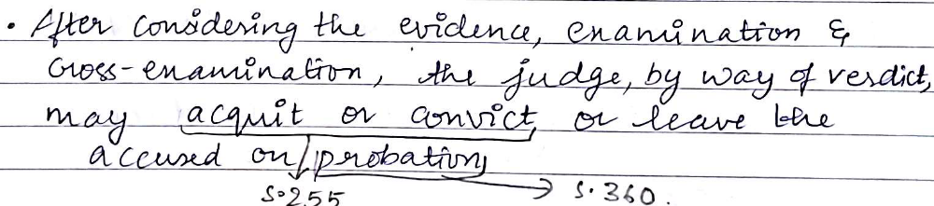


Warrant Trials
Warrant case upon a FIR : 154 - 157 – 160 – 162 – 173 – 190(1)(b) - 238 – 239 – 240 – 241 – 242 – 313(b) – 243 – 248 – acquittal/ conviction/ probation.
Warrant case upon a Complain: Based on S200 there is pre summoning – 202 – 203 – 204(can apply for bail) – 244 – 245(prima facie, yes convict no acquittal) – 246 – 247 – 248
Sessions Trials: 209, 226 – 237
General Provisions as to Enquiries and Trials
- Rule against Double Jeopardy:
S 300 lays down that a person once convicted or acquitted by a court of competent juris cannot be tried again on the same facts while the conviction or acquittal is in force
- Tender of Pardon to an accomplice (306-308)

- Non-compliance: 308 (1) provides for it and the person can be tried for the offence in respect of which the pardon was tendered.

- Can an accused become a witness? If so when? 315

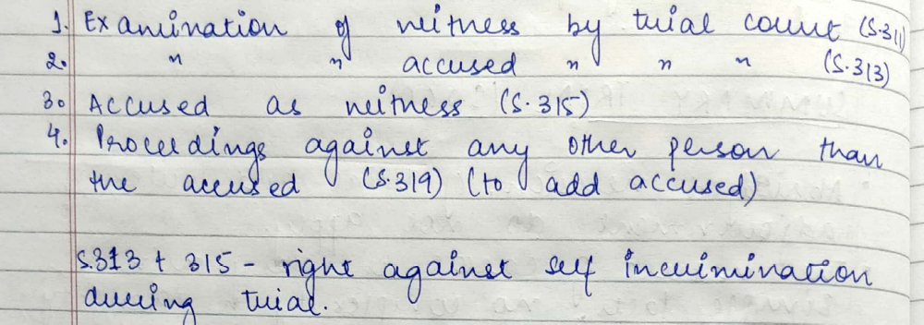
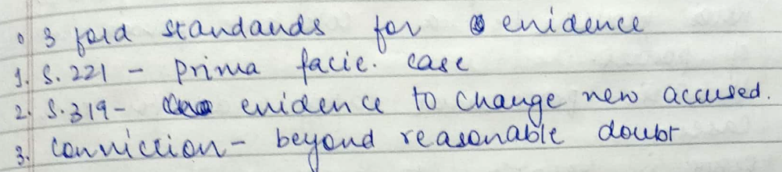
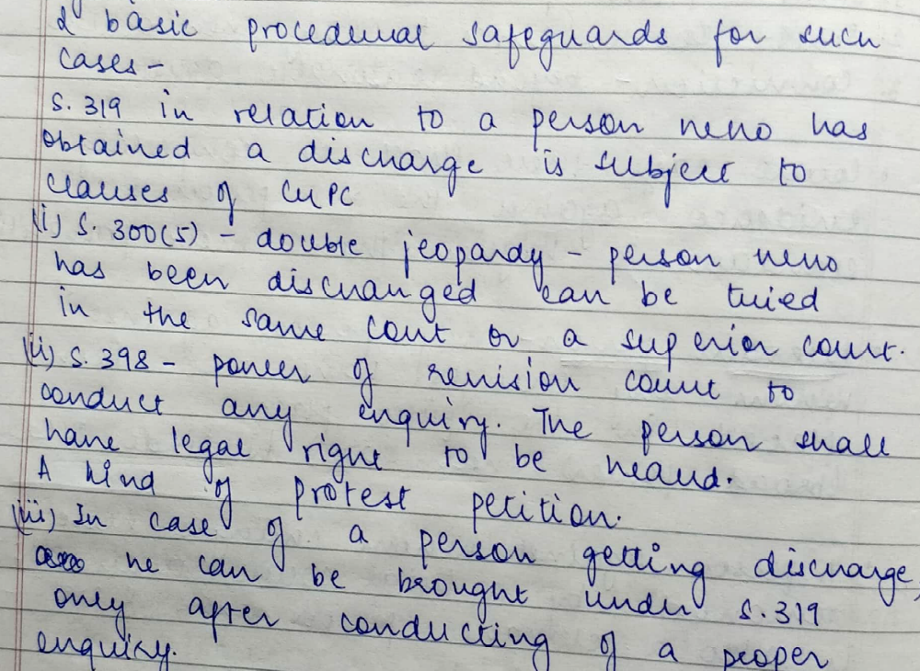

Irregular proceedings: 460-466
Failure of justice – if objection could have been earlier (465(2)
Sec 460 – Proceedings not to be set aside just coz he’s not empowered
Sec 461 – Proceedings void
Cases –
- Bhagyan Das v. State of Uttarakhand - Merely because an offence is compoundable Under Section 320 Code of Criminal Procedure still discretion can be exercised by the court having regard to nature of offence, as such it is rightly held in the impugned judgment that as the offence for which Appellant was convicted and sentenced, it will have its own effect on the society at large.

- Dharam Pal v. State of Haryana - The power of the High Court Under Article 226 of the Constitution cannot be taken away, curtailed or diluted by Section 6 of the Special Police Act. (However, it should be used sparingly)

- Kamil v. State of UP- A conviction for substantive offence without a charge could be set aside only if Accused showed that, prejudice had been caused to him and that “failure of justice” had occasioned thereby.

- Kewal Krishan v. Saroj Bhan - Evaluation of evidence which has not resulted in miscarriage of justice does not vitiates Magistrate’s Order but is only a mere procedural irregularity

- Kishun Singh v. State of Bihar - On the magistrate committing the case under Section 209 to the Court of Session the bar of Section 193 is lifted thereby investing the Court of Session complete and unfettered jurisdiction of the court of original jurisdiction to take cognizance of the offence which would include the summoning of the person or persons whose complicity in th0e commission of the crime can prima facie be gathered from the material available on record

- Mahesh Chand v. State of Rajasthan – A non-compundable offence may be compunded by a High court

- R. Rachiah v. Home Secretary, Bangalore - The procedure u/s. 216 & 217 is mandatory and not directory

- State of MP v. Lakshmi Narayan - Yes the HC can quash the FIR under S482 but it may not do it in cases of heinious crimes affecting society at large. But not in this case because the HC did not assess the complete circumstances, nor did it apply its mind towards the nature of the offence and its impact on the society at large

- State of Orissa vs. Debendra Nath Padhi – No.
- Section 91 does not confer any right on accused to produce document in his possession to prove his defence.
- Section 227 of the Code of Criminal Procedure, 1973 (Code) provides for the eventuality when the accused shall be discharged.
BAIL: 50,57,167,209B, 436-450
437(1)(4) 439
The Article 21- right to life and personal liberty is most important than other rights mentioned in Articles 19-20 and 22 of the Constitution. The main interpretation of this article infers that when the bail is denied then the personal liberty of an accused is refused. Hence, when a large number of bail cases come to the higher court, the court interprets them in the light of Article 21.
The Supreme Court of India observed that “grant of bail is a rule and refusal to bail is an exception
The principle purpose of1 bail is to ensure that an accused person will return for trial if he is released after arrest.
Section 50(2) makes it obligatory for a police officer arresting such a person to inform him of his rights to be released on bail. But if the offence is non-bailable that does not mean that the person accused of such offence shall not be released on bail, but here in such a case bail is not a matter of right, but only a privilege to be granted at the discretion of the court.
A proviso to Section 437(1) to the effect that a person who has been accused of offences punishable with death, life imprisonment or imprisonment for seven years or more shall not be released on bail without giving an opportunity of hearing to the Public Prosecutor
S 436- bail would be granted as a matter of course if the person arrested is willing to furnish bail whereas, in case of non bailable offence S437 & S 439 – cannot be claimed as a matter of right and grant of bail or not would depend on facts and circumstances of the case. Unlike S 436- Conditions may be imposed on S 437.
Conditional Bail - While granting bail in the above mentioned conditions (1) and (2) the court may impose any condition which it considers necessary-to ensure that such person shall attend in accordance with the conditions of the bond executed under Chapter XXXIII (i.e, relating to bail); or – in order to ensure that such person shall not commit an offence similar to the offence of which he is accused of or the commission of which he is suspected of; or-that such person shall not directly or indirectly make any inducement or threat or promise to any person acquainted with the facts of the case so as to dissuade him from disclosing such facts to the court or to any police officer or tamper with the evidence.
Powers of Police to grant bail - In accordance with the powers of the CrPC and certain other Acts, police has powers to grant bail in the offences generally categorized as bailable offences. But after the challans are filed in the court, the accused person has to fill in the prescribed bail bond in order to get regular bail from the court of competence.
Cancellation of Bail- Section 437(5) and Section 439(2)
Anticipatory Bail- Section 438
The discretion given to the Court in admitting the accused to bail is to be exercised judicially. S 397(1) powers to release on bail have been given to Appellate Court. Courts exercising Revisional jurisdiction (HC and Sessions Court) has been given similar power during pendency of revisional proceedings.
Note- SC is not an appellate court. The public prosecutor has been given right to seek cancellation of bail.
Cases –
- CBI v. Anupam J. Kulkarni – 1. In case accused is detained in police custody maximum period during which he can be kept in such custody is only 15 days either pursuant to single Order or more than one such Order are for lesser number of days
2. Such custody cannot be beyond 15 days and further remand to facilitate
investigation can only be by detention of accused under judicial custody.

- Gurbaksh Singh Sibbia Vs. State of Punjab - Section 438 (1) lays down conditions to be satisfied before granting anticipatory bail
- Applicant must show that he has ‘reasons to believe’ that he may be arrested for some non-bailable offence.
- Filing of first information report (FIR) is not condition precedent to exercise power under Section 438 (1).
- Bail under Section 438 (1) can be granted even after FIR so long as arrest is not
Made.
- The object of bail is to secure the attendance of the accused at the trial, that the proper test to be applied in the solution of the question whether bail should be granted or refused is whether it is probable that the party will appear to take his trial and that it is indisputable that bail is not to be withheld as a punishment.
- It was observed that the principle to be deduced from the various sections in the Criminal Procedure Code was that grant of bail is the rule and refusal is the exception -
- An accused person who enjoys freedom is in a much better position to look after his case and to properly defend himself than if he were in custody.
- As a presumably innocent person he is therefore entitled to freedom and every opportunity to look after his own case.
- A presumably innocent person must have his freedom to enable him to establish his innocence

- Gurcharan Singh v. State - 1. If it is clear from evidence and eye witness that offence is non bailable due to likelihood of accused fleeing from place or of tampering with evidence, he must be denied bail 2. Unless exceptional circumstances are brought to the notice of the court which may defeat appropriate investigation and a fair trial, the court will not decline to grant bail to a person who is not accused of an offence punishable with death or imprisonment for life.
- It is also clear that when an accused is brought before the court of a Magistrate with the allegation against him of an offence punishable with death or imprisonment for life, he has ordinarily no option in the matter but to refuse bail subject, however, to the first proviso to Section 437(1), Cr. P.C
- In a case where the Magistrate entertains a reasonable belief on the material that the accused has not been guilty of such an offence.
- This will, however, be an extraordinary occasion since there will be some material at the stage of initial arrest, for the accusation or for strong suspicion of commission to try the persons of such an offence

- Hussainara Khatun v. Home Secretary, State of Bihar – 1) The pre-trial release on personal bond i.e, without surety should be allowed where the person to be released on bail is indigent and there is no substantial risk of his absconding. 2) Accused has a right to claim speedy trial and if there is unreasonable delay, such an accused must be released on bail. 3) The Court while dealing with the cases of under trials who had suffered long incarceration held that a procedure which keeps such large number of people behind bars without trial so long cannot possibly be regarded as reasonable, just or fair so as to be in conformity with the requirement of Article 21.

- Sanjay Chandra vs. CBI - Bail applications, generally, it has been laid down from the earliest times that the object of bail is to secure the appearance of the accused person at his trial by reasonable amount of bail 1. The object of bail is neither punitive nor preventative

2. Deprivation of liberty must be considered a punishment, unless it can be required to ensure that an accused person will stand his trial when called upon.
3. The courts owe more than verbal respect to the principle that punishment begins after conviction, and that every man is deemed to be innocent until duly tried and duly found guilty 4. Apart from the question of prevention being the object of a refusal of bail, one must not lose sight of the fact that any imprisonment before conviction has a substantial punitive content and it would be improper for any Court to refuse bail as a mark of disapproval of former conduct whether the accused has been convicted for it or not or to refuse bail to an un-convicted person for the purpose of giving him a taste of imprisonment as a lesson.

- State of Madhya Pradesh v. Rustom – 1. The day on which the accused remanded to the judicial custody would be excluded and the day on which challan filed in the court should be included. 2. Right to compulsive bail under s.167(2) does not survive after filing of the challan

- State vs Jaspal Singh - Court while granting bail where the trial had not commenced should take into consideration various matter such as nature and seriousness of offence, the character of evidence, a reasonable possibility of the presence of the accused not being secured at the trial and a reasonable apprehension of witnesses being tampered with.

- R. Rathinam vs State by DSP - it was held by a division bench of the Supreme Court that a third party can file an application for cancellation of bail. In such a way the third party is reminding the court of the need to exercise its own power to start suo motu proceedings in this regard.
3. Section 439(1), Cr. P.C. of the new Code, on the other hand, confers special powers on the High Court or the Court of Session in respect of bail
- Unlike under Section 437(1) there is no ban imposed under Section 439(1), Cr. P.C. against granting of bail by the High Court or the Court of Session to persons accused of an offence punishable with death or imprisonment for life
- It is, however, legitimate to suppose that the High Court or the Court of Session will be approached by an accused only after he has failed before the Magistrate and after the investigation has progressed throwing light on the evidence and circumstances implicating [exculpating] the accused.

Judgment and Sentencing

Judgment – Sec 353,354,357,360(1)(3)
Section 360(1): Probation
Section 360(3): Admonition
Section 235(2): Judgment of Acquittal or Conviction (Court of Sessions)
Sentencing - Sec 366 – 369
Sections 366 and 367: Confirmation of Death Sentence by the High Court
Sections 413 and 414: Execution of Death Sentence
Section 31: Consecutive/Concurrent Sentences of Imprisonment
Section 30: Sentence of Imprisonment in Default of Fine
Sections 63 and 67 IPC: Sentence of Fine
Section 432: Suspension/Remission of Sentence
Section 433: Commutation of Sentence

Appeals – Sec 372 - 394
374 – appeal conviction , exceptions - 375,376
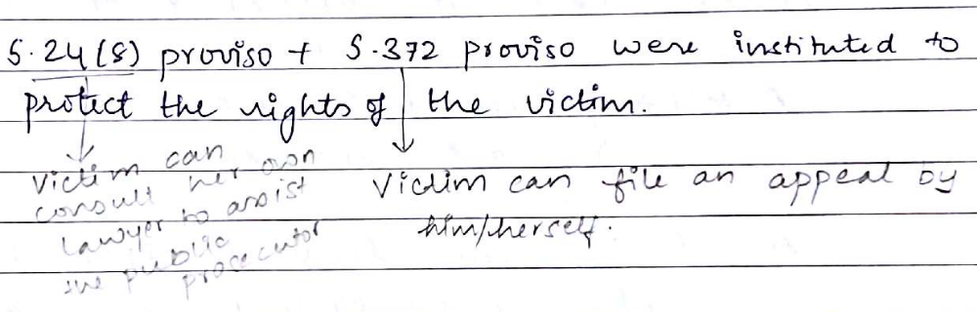
Revision and Reference – 395 - 405
CASES –
- Balwant Singh v. State of Punjab - It would thus be noticed that awarding of the sentence other than the sentence of death is the general rule now and only special reasons, that is to say, special facts and circumstances in a given case, will warrant the passing of the death sentence. (professional, on a child or woman)

- Maru Ram vs Union of India – the constitutional validity of Section 433-A was upheld. Sec 433 won’t affect cases before 1978

- Nahar Singh Yadav v Union of India – 406-408-Transfer of trial only In exceptional cases where necessary for credibility of trial. 1) if miscarriage of justice, 2) harm to complainant, 3) inconvenience and hardships while travelling and expense, 4) interference with course of justice, 5) communal problems

- Satya Pal Singh v. State of MP – 372,378(3)-The victim can file an appeal & follow the procedure as a complainant. The appeal filed by the victim lies in the HC under S378(4)

- Sheetala Prasad v. Srikant – 401(3) High Court had exercised revisional jurisdiction with material illegality and irregularity resulting into miscarriage of justice, hence its order was liable to be set aside.

- Malikarjun Kodagali vs. State of Karnataka – 372,378 - a victim can also file an appeal under Section 372 of the Criminal Procedure Code without prior approval of the appellate court

