To

The Deputy Governor
Reserve Bank of India, Central Office
1st Floor, Amar Building
Sir P.M.Road
Mumbai – 400 001

Sub: Appeal Against the decision of the Banking Ombudsman, Bangalore

Dear Sir,

I am the customer of Bank of India, Ramakrishnapuram Branch, Secunderabad . I have a Joint Pension a/c no SB 860410110002547 (since May 2008) and a single a/c no SB 860410110003973 (opened under compulsion) since Feb 2010). I retired from service on 31 Jan 2009. I submit this appeal against the decision of the Banking ombudsman, Hyderabad in respect of the following complaint:-
A. Name of the Appellant: Lt Col Retd Haridas Mandal
B. Name of the Complainant: Lt Col Retd Haridas Mandal
C. Name of the Bank: Bank of India
D. Date of Complaint: 10 Sep 2013
E. BO Acknowledgement: 15 Oct 2013

F. BO disposal : 28 Mar 2014
I hereby enclose a copy each of my complaint as well as BO reply for more information.
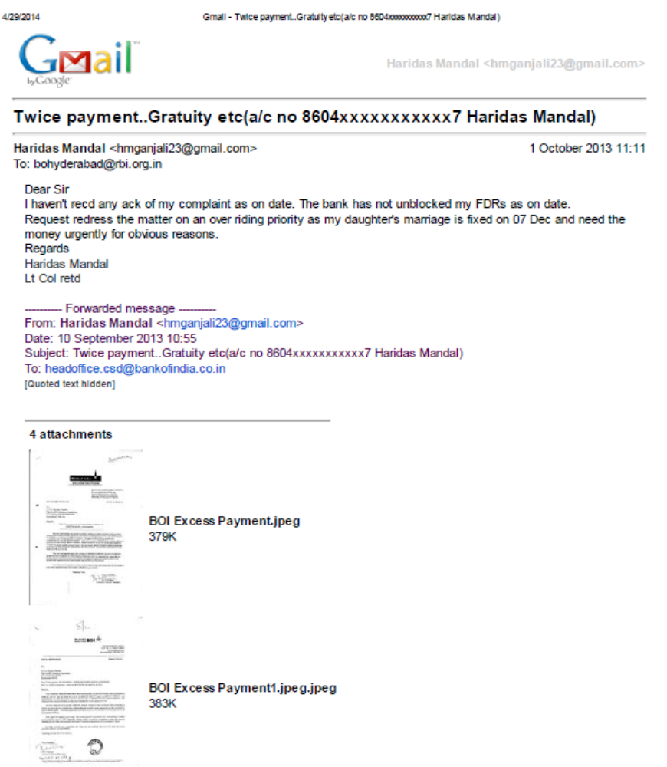

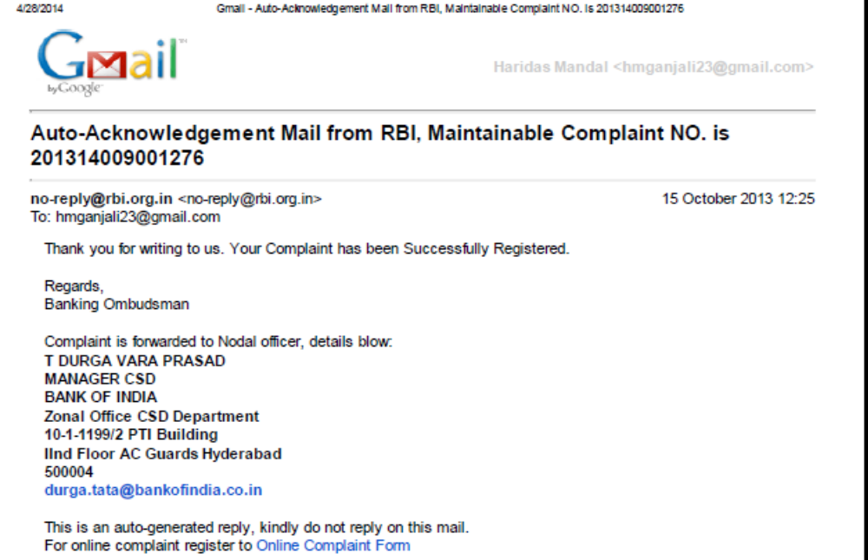
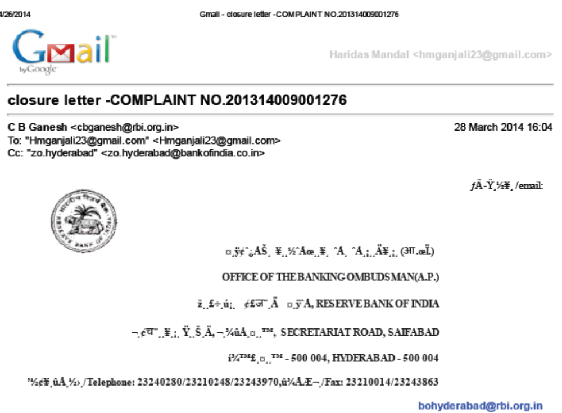

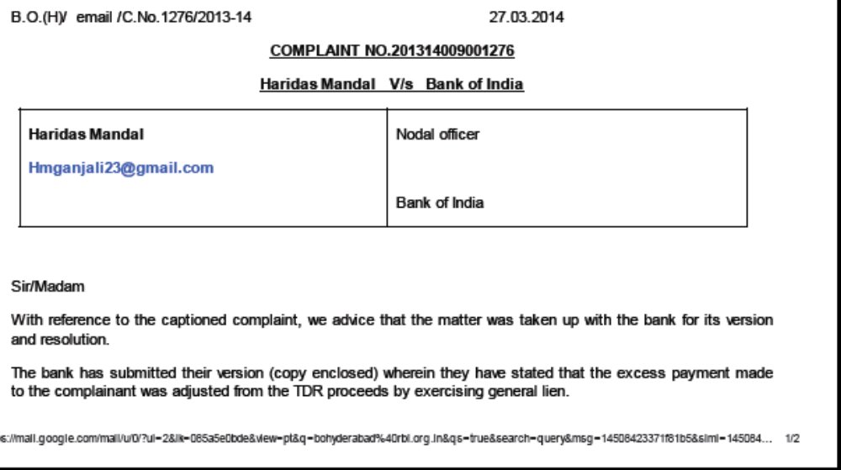
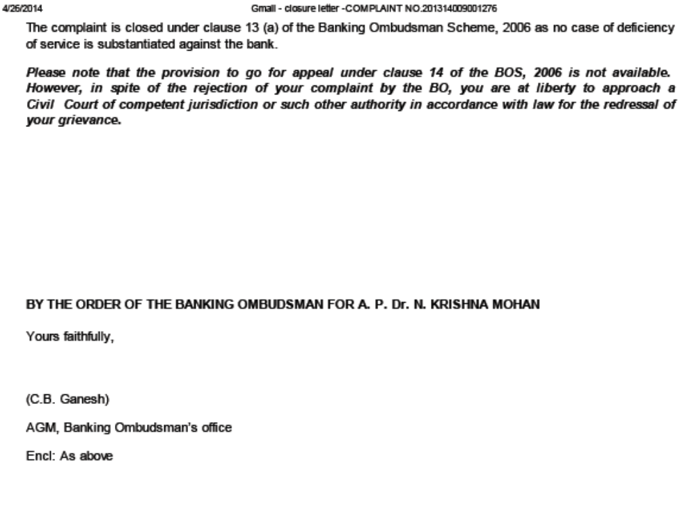

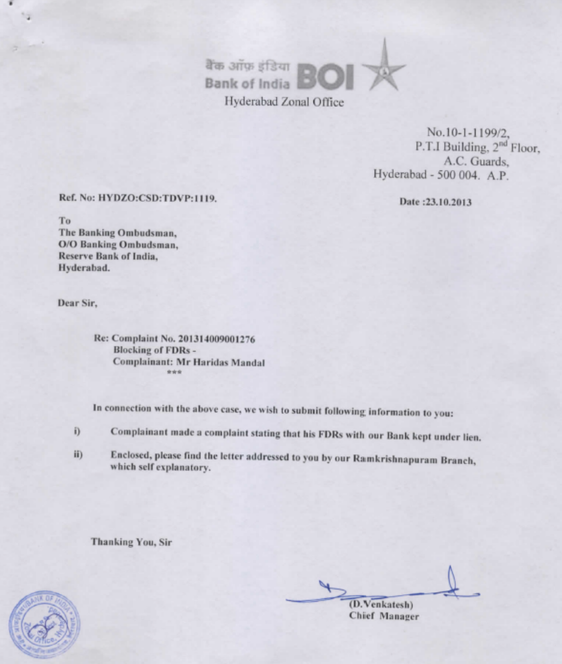

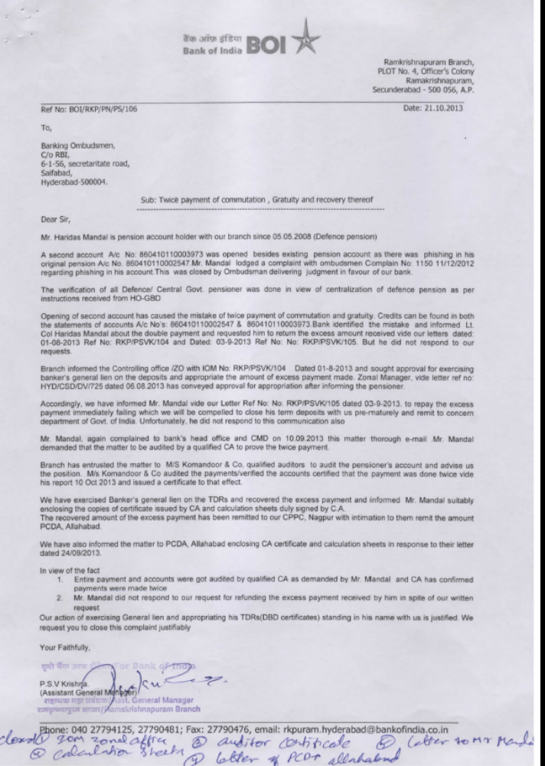
G. Grounds of Appeal:-
1. I contest the ruling of the BO as biased, incorrect and designed to unfairly favour the Bank at the cost of the customer.
That the BO Hyd had acknowledged receipt of my complaint as a maintainable complaint No 201314009001276 dated 15 Oct vide its email dated 18 Oct 2013. The BO has invoked clause 11(1) …
(1) As soon as it may be practicable to do, the Banking Ombudsman shall send a
Copy of the complaint to the branch or office of the bank named in the complaint,
under advice to the nodal officer referred to in sub-clause (3) of clause 15, and
endeavor to promote a settlement of the complaint by agreement between the
Complainant and the bank through conciliation or mediation.
…to obtain information under clause 10(1).
(1) For the purpose of carrying out his duties under this Scheme, a Banking
Ombudsman may require the bank against whom the complaint is made or any
other bank concerned with the complaint to provide any information or furnish
Certified copies of any document relating to the complaint which is or is alleged to
be in its possession.
That it has self admitted receipt of bank’s reply dated 23 Oct 2013 against my complaint and relied on it..
Sir/Madam
With reference to the captioned complaint, we advice that the matter was taken up with the bank for its version and resolution. The bank has submitted their version (copy enclosed) wherein they have stated that the excess payment made to the complainant was adjusted from the TDR proceeds by exercising general lien. The complaint is closed under clause 13 (a) of the Banking Ombudsman Scheme, 2006 as no case of deficiency of service is substantiated against the bank.”

That the BO by aligning with the bank’s version uncontested {(as the BO did not give a reasonable opportunity to the complainant under clause 12 (1) or took into account the evidence ..the principles of banking &practice….and such other factors which ….are relevant to the complaint under clause 12(2)}…
12. AWARD BY THE BANKING OMBUDSMAN
(1) If a complaint is not settled by agreement within a period of one month from
the date of receipt of the complaint or such further period as the Banking
Ombudsman may allow the parties, he may, after affording the parties a
reasonable opportunity to present their case, pass an Award or reject the
complaint.
(2) The Banking Ombudsman shall take into account the evidence placed before
him by the parties, the principles of banking law and practice, directions,
instructions and guidelines issued by the Reserve Bank from time to time and
such other factors which in his opinion are relevant to the complaint.

..has therefore deemed to have rejected my complaint under clause 13(f) and has erred knowingly or unknowingly to claim to have closed under clause 13 (a) of the Banking Ombudsman Scheme 2006 as amended.
That the BO has therefore erred in invoking clause 14 stating..
Please note that the provision to go for appeal under clause 14 of the BOS, 2006 is not available.
However, in spite of the rejection of your complaint by the BO, you are at liberty to approach a
Civil Court of competent jurisdiction or such other authority in accordance with law for the redressal of your grievance.

That I consider that the decision is arbitrary and blatantly flawed as the BO relied on the submission made by the Branch Manager taking that as the gospel truth disregarding all other evidence, directives, orders etc available to him. The BO neither called for a reconciliation meeting nor offered chances to the complainant to file his counter affidavit. The decision was given by the BO in direct contradiction to the provision PCDA (Pensions) Allahabad Circular No 141 of 2009 (copy attached for ready ref) though binding on the bank.
That my complaint factually disposed of invoking clause 13(f) but knowingly claimed to be under clause 13(a) only to debar me to file my appeal to the Dy Governor RBI as enshrined in clause 14(1) of BO Rules 2006 as amended.
That if I am not provided the option to appeal and the decision is not reviewed, it would mean that any BO can take an arbitrary decision and declare it as a decision under clause 13(a), collude with the Banker and defeat the very objective of the Banking Ombudsman Scheme 2006. (BOS) as amended.
2. The BO has failed to follow due process as recommended in the BOS-2006 in arriving at his decision. Lack of due process is also an indication of the biased nature of the decision.
Substantiation:
3. Facilitation of Mediation is the essence of BOS
3.1: According to Rule 7(2) of the Banking Ombudsman Scheme 2006 (BOS) the Banking Ombudsman (BO), “...shall facilitate their (eg: disputes) satisfaction or settlement by agreement or through conciliation and mediation between the Bank concerned and the aggrieved parties...”
3.2: Again according to rule 11 (1) the BO ought to have endeavored to “promote a settlement of the complaint by agreement between the complainant and the Bank through conciliation or mediation”, following “Such procedure as he may consider just and proper”
3.3: It is evident from the study of the Banking Ombudsman Scheme (BOS) that the scheme is envisaged as a facilitation of a “Mediation Process” where the Banking Ombudsman being a respected officer of the regulator brings the disputing customer and the Bank to a negotiating table to discuss the dispute and find a resolution.
3.4: However, despite my specific and repeated requests, the BO failed to organize a mediation meeting and proceeded to arrive at his decision solely based on a written response received by him from the Bank which was inadequate and misleading. A copy of the written submission by the bank was provided to me only when my complaint was disposed off under Clause 13(a) of BO Rules 2006.
3.5: The BOS does not envisage the BO to simply accept a statement given by the Bank as the truth and only the truth and reject even an opportunity for the complainant to present his case.
3.6: : By not giving an opportunity for the complainant to represent his case both before the Ombudsman himself and in a joint settlement meeting, the complainant has been denied an option to discuss the matter with the senior officials of the Bank and providing the necessary clarifications.
3.7: This is completely against the spirit of the BOS which is meant to improve the customer satisfaction. Instead of assisting the customer in resolving the dispute by appropriately mediating in the dispute resolution, the Banking Ombudsman has come to a judgment in total disregard to the duty cast upon him to facilitate the resolution of the dispute.
4. Unreliable Information Considered by BO:
4.1: According to the copy of the BO order, he has considered the following documents to arrive at his conclusion.
a) A reply from the Chief Manager Hyderabad Zonal dated 23 Oct 2013 to the banking ombudsman consisting of the following supporting documents:-
i) A written submission from the Br Manager Bank of India RK Puram Br addsd to the Banking Ombudsman Hyderabad dated 21 Oct 2013 (1 page)
ii) An audit report from a privately engaged Chartered Accountant (M/s Komandoor & Co Hyd) submitted on 10 Oct 2013 along with four roughly prepared tabulation sheets (6 pages)
iii) A letter from the bank to the PCDA dated 17 -10.2013 informing them of recovery of Rs 15, 23,021.00 from the proceeds of FDRs held in my name in the same branch (1 page)
d) A letter from the bank dated 11 .10.2013 informing me details of Principal component and the interest components of the forced closed of my FDRs and its appropriation by the bank (1 page)
The information considered is unauthenticated and lacks credibility for reasons stated Para-wise:-
4.2: Para 1- “ Mr Haridas Mandal is pension account holder with our branch since 05.05.2008 (Defence Pension). My Reply:-True. I had my joint pension acct no 860410110002547 opened as mandatory 8 months in advance since 05.05.2008.
4.2 : Para 2 –“ A second A/C No 860410110003973 was opened…..judgment in favour of the bank” .My Reply:- My pension A/C was hacked for Rs 90,000.00 on 01/02 Jan 2010 (vide extract of statement of A/C for 01/02 Jan 2010 attached as at Appx B) supposedly from Australia, Canada & Nigeria (vide para (e) at page 2 of their letter No HYDZO:CSD:KRR:041 dated 30.04.2010 to the BO Hyd attached as at Appx C) only to be credited to Indian customers having A/C with the Branches of Bank of India in and around their Head Office at Mumbai ( vide their letter No HYDZO:CSD:KRR: 088 dated 19.05.2010 as at Appx D). According to the bank there had been phishing attack on my pension acct so they kept it blocked for the past two months only to UNBLOCK it at 17:02hrs on 01.02.2010 vide their email dated 01 Jan 2010 copy att as at Appx E).The bank allowed the hackers at Australia, Canada & Nigeria to hack Rs 90,000.00 from my pension acct to the beneficiary acct in Bank of India Branches in and around their head office on 01/02 Jan 2010 & then to safe guard my interest blocked my acct immediately. They informed me of the hacking on 03 Jan 2010 but forgot to block the acct of the beneficiaries. On the same day they compelled me to open another savings acct internet enabled for my day to day usage (Single SB ac no 860410110003793). It was opened in Feb 2010. They promised me to recover hacked money from their known customers soon but didn’t. I lodged a complaint with the BO. It was admitted vide complaint regn no Complaint No. 200910009004723. BO Hyd heard the case in its office. During hearing before the BO the banking official retracted from their stand and called those transactions as VALID INTERNET TRANSFERS and blamed me for compromising my credentials with the hackers vide their submission as at appx C. The BO ruled the transactions as VALID INTERNET TRANSACTIONS and showed its inability to investigate the case further (vide their order dated 05 Jul 2010 copy att as at Appx F). The bank has not recovered the money from their known customers as on date. Hence technically there was no phishing attack but valid internet transfers. Taking excuse of a phishing attack on my pension acct which they themselves plead against before the BO can’t be an excuse.
4.3 Para 3-“Verification of all Defence / Central Govt pensioner…..recd from HO-GBD”. My Reply: No comments as I have not received any communication from PCDA in this regard. Whether it was long over due or not done according to the standing orders could be of academic interest to the controlling authority as well as the PCDA. All their arguments have gone for a six as they have failed to consider a PPO No M/DIS/6180/2013 as stated by PCDA now.
4.4 Para 4- “Opening of second acct has caused…….did not respond to our requests”. My reply: - Pension Pay Orders are account payable and there was no change of status for my joint pension acct. So confusion / mistake or criminality was not due to opening of second acct but lies somewhere else. The issue is whether the (1) defence pensioner was informed? (2)Did he respond? (3)Did he concur? If not, whether it was (4) mandatory for the bank to intimate PCDA? If it intended to go ahead without concurrence either of the defence pensioner or the PCDA (5) what option it had? Taking the questions one by one we get (1) The bank informed the pensioner on 01 Aug 2013 and sought permission from ZO on the same day to foreclose all his FDRs .(2) The pensioner responded immediately asking the bank to provide all the details when personal meetings with the manager yielded no results.(3) No he did not. (4) It was not mandatory for the bank if it intended to recover without approval from PCDA as well concurrence of the defence pensioner. (5) As per Para 1 serial (i) of circular No 141 the bank, as a paying branch, had only option “not to overlook the prescribed rates of recovery to be affected from the pensioners as mentioned in Para 1”.. of the above circular No 141.. “ since the Govt orders provide for only recovery of over paid pensioner, except where specific Govt orders have been issued for recovery of overpayment from the arrears of pension”. The bank did not take approval of the PCDA. The defence pensioner did not concur. In that situation the bank had no option but to recover an amount equivalent to one third of the monthly pension, even if the pensioner was overpaid.
.
4.5 Para 5 :- “ Branch informed the Controlling Office…..conveyed approval for appropriation after informing the pensioner” My Reply:-The question arises {even if there was alleged over payment (quantum may vary as PPO No M/DIS/6180/2013 was not taken into account and the Private CA was not the final auth to interpret my dues against PPO No M/SCJ/030214/2013)} (1) whether the Branch Manager was ignorant of the provision of para 1 of the circular No 141? (2) Was the Zonal Manager equally ignorant of the said provision? (3) Is it natural to assume that Branch Manager to Zonal Manager to Nodal Manager to CMD of the PDA Bank was ignorant of the existence of circular No 141? (4) Under what exact provision the worthy branch manager sought permission on 01 Aug 2013 from the Zonal Manager ? (5) And lastly under what extant rule the Zonal Manager gave such permission? Truth is :-(1) to (3)The Br Manager first delayed my pension probably to recover one third of pension. It is on record. It is safely to assume that Managers at all levels from Br to Zonal to CMD of Bank of India were aware of the provisions of the circular No 141. (4) to (5) The lightning speed at which the Zonal Manager issued his approval, compels one to believe that they were conspiring big to appropriate the interest component to their TEA Party office acct

4.6 Para 6 “Accordingly we have ……..he did not respond to this communication also”. My Reply :- Govt of India Min of Defence through its circular No 141 issued by PCDA Allahabad to all the CMD had made its stand crystal clear. It had informed me and I had asked them to unblock my FDRs and informed all the managers at all levels including CMD of the bank.
4.7 Para 7: “Mr Mandal …….CA to prove the twice payment”. My Reply:-It is the PCDA which is the arbitrator in defense pension matters. Or else the bank had option to act as per provision as at para 1 of the circular 141. Engaging a private CA for a concocted report was not an option available to them. Further at one moment they claim that the defence pensioner did not respond and in the same breath they claim it is as per wishes of the defence pensioner that private CA was engaged. It questions the very integrity of the Br Managers to ZO to Chief Managing Director of BOI.
4.8 Para 8 –“Branch has entrusted the matter to ………and issued a certificate to that effect”. My reply: -- Bank was at a liberty to engage thousand & one CA of their choice to satisfy themselves if they think their staff is incompetent. But to use the certificate issued by one such non-entity to eliminate PCDA from its prime role with authority makes the PDA PSU Bank a laughing stock. Hence not commented upon.
4.9 Para 9:-“We have exercised …. with intimation to PCDA Allahabad. We have also informed…….dated 24/09/2013”. My Reply :- The bank had no option but to comply with the order on recovery of alleged excess payment as per para 1 of the circular No 141. It had no power of banker’s general Lien with or without approval from its controlling office/ZO.
On the CA’s audit report , suffice it to mention that “two pages of rough calculation sheets showing payable /paid statement” sent to me by the bank along with their letter dated 01 Aug 2013 ironically are the “same two pages “photo stated” found enclosed with the CA’s audit report dated 10 Oct 2013. PPO No M/DIS/6180 /2013 was not even mentioned in the CA’s audit report. Such report best be discarded. It is another matter that the bank went ahead to appropriate the interest component of Rs 3,84,000.00 to their office TEA Party account without any certificate from the said CA.
The bank had no intention to inform PCDA till I made a complaint to the Govt of India Min of Defence vide my complaint dated 14 Sep 2013..
Lodge a Grievance |  | Lodge Reminder/Clarification |  | View Status |  | Change Password |  | Forgot Password

Grievance Status
Print || Logout

Status as on 27 Apr 2014
Registration Number | : | DOPPW/E/2013/02066
Name Of Complainant | : | Lt Col Retd Haridas Mandal
Date of Receipt | : | 14 Sep 2013
Received by | : | Department of Pension and Pensioners Welfare
Forwarded to | : | PR. CDA PENSION ALLAHABAD
Contact Address | : | DRAUPADI GHAT
 |  | ALLAHABAD
 |  | UP211014
Contact Number | : | 05322420210
Grievance Description | : | Bank has marked my FDRs worth 18 Lacs as lien stating that a sum of Rs 15 Lacs had been paid in excess in my pension acct. They are not ready to share with any further details to verify their claims. I am not in receipt of any letter from CDA pension.
Current Status | : | CASE CLOSED
Your Feedback | : | Average
Date of Action | : | 27 Sep 2013
Details | : | REPLY FURNISHED VIDE THIS OFFICE LETTER NO. AT/PSB/IV/SEC'BAD/AP/CPGRAM DATED 24/09/2013. A COPY OF REPLY IS ATTACHED.

That PCDA acted only when complaint was lodged & asked the Bank to furnish all details vide their letter dated 24 Sep 2013..
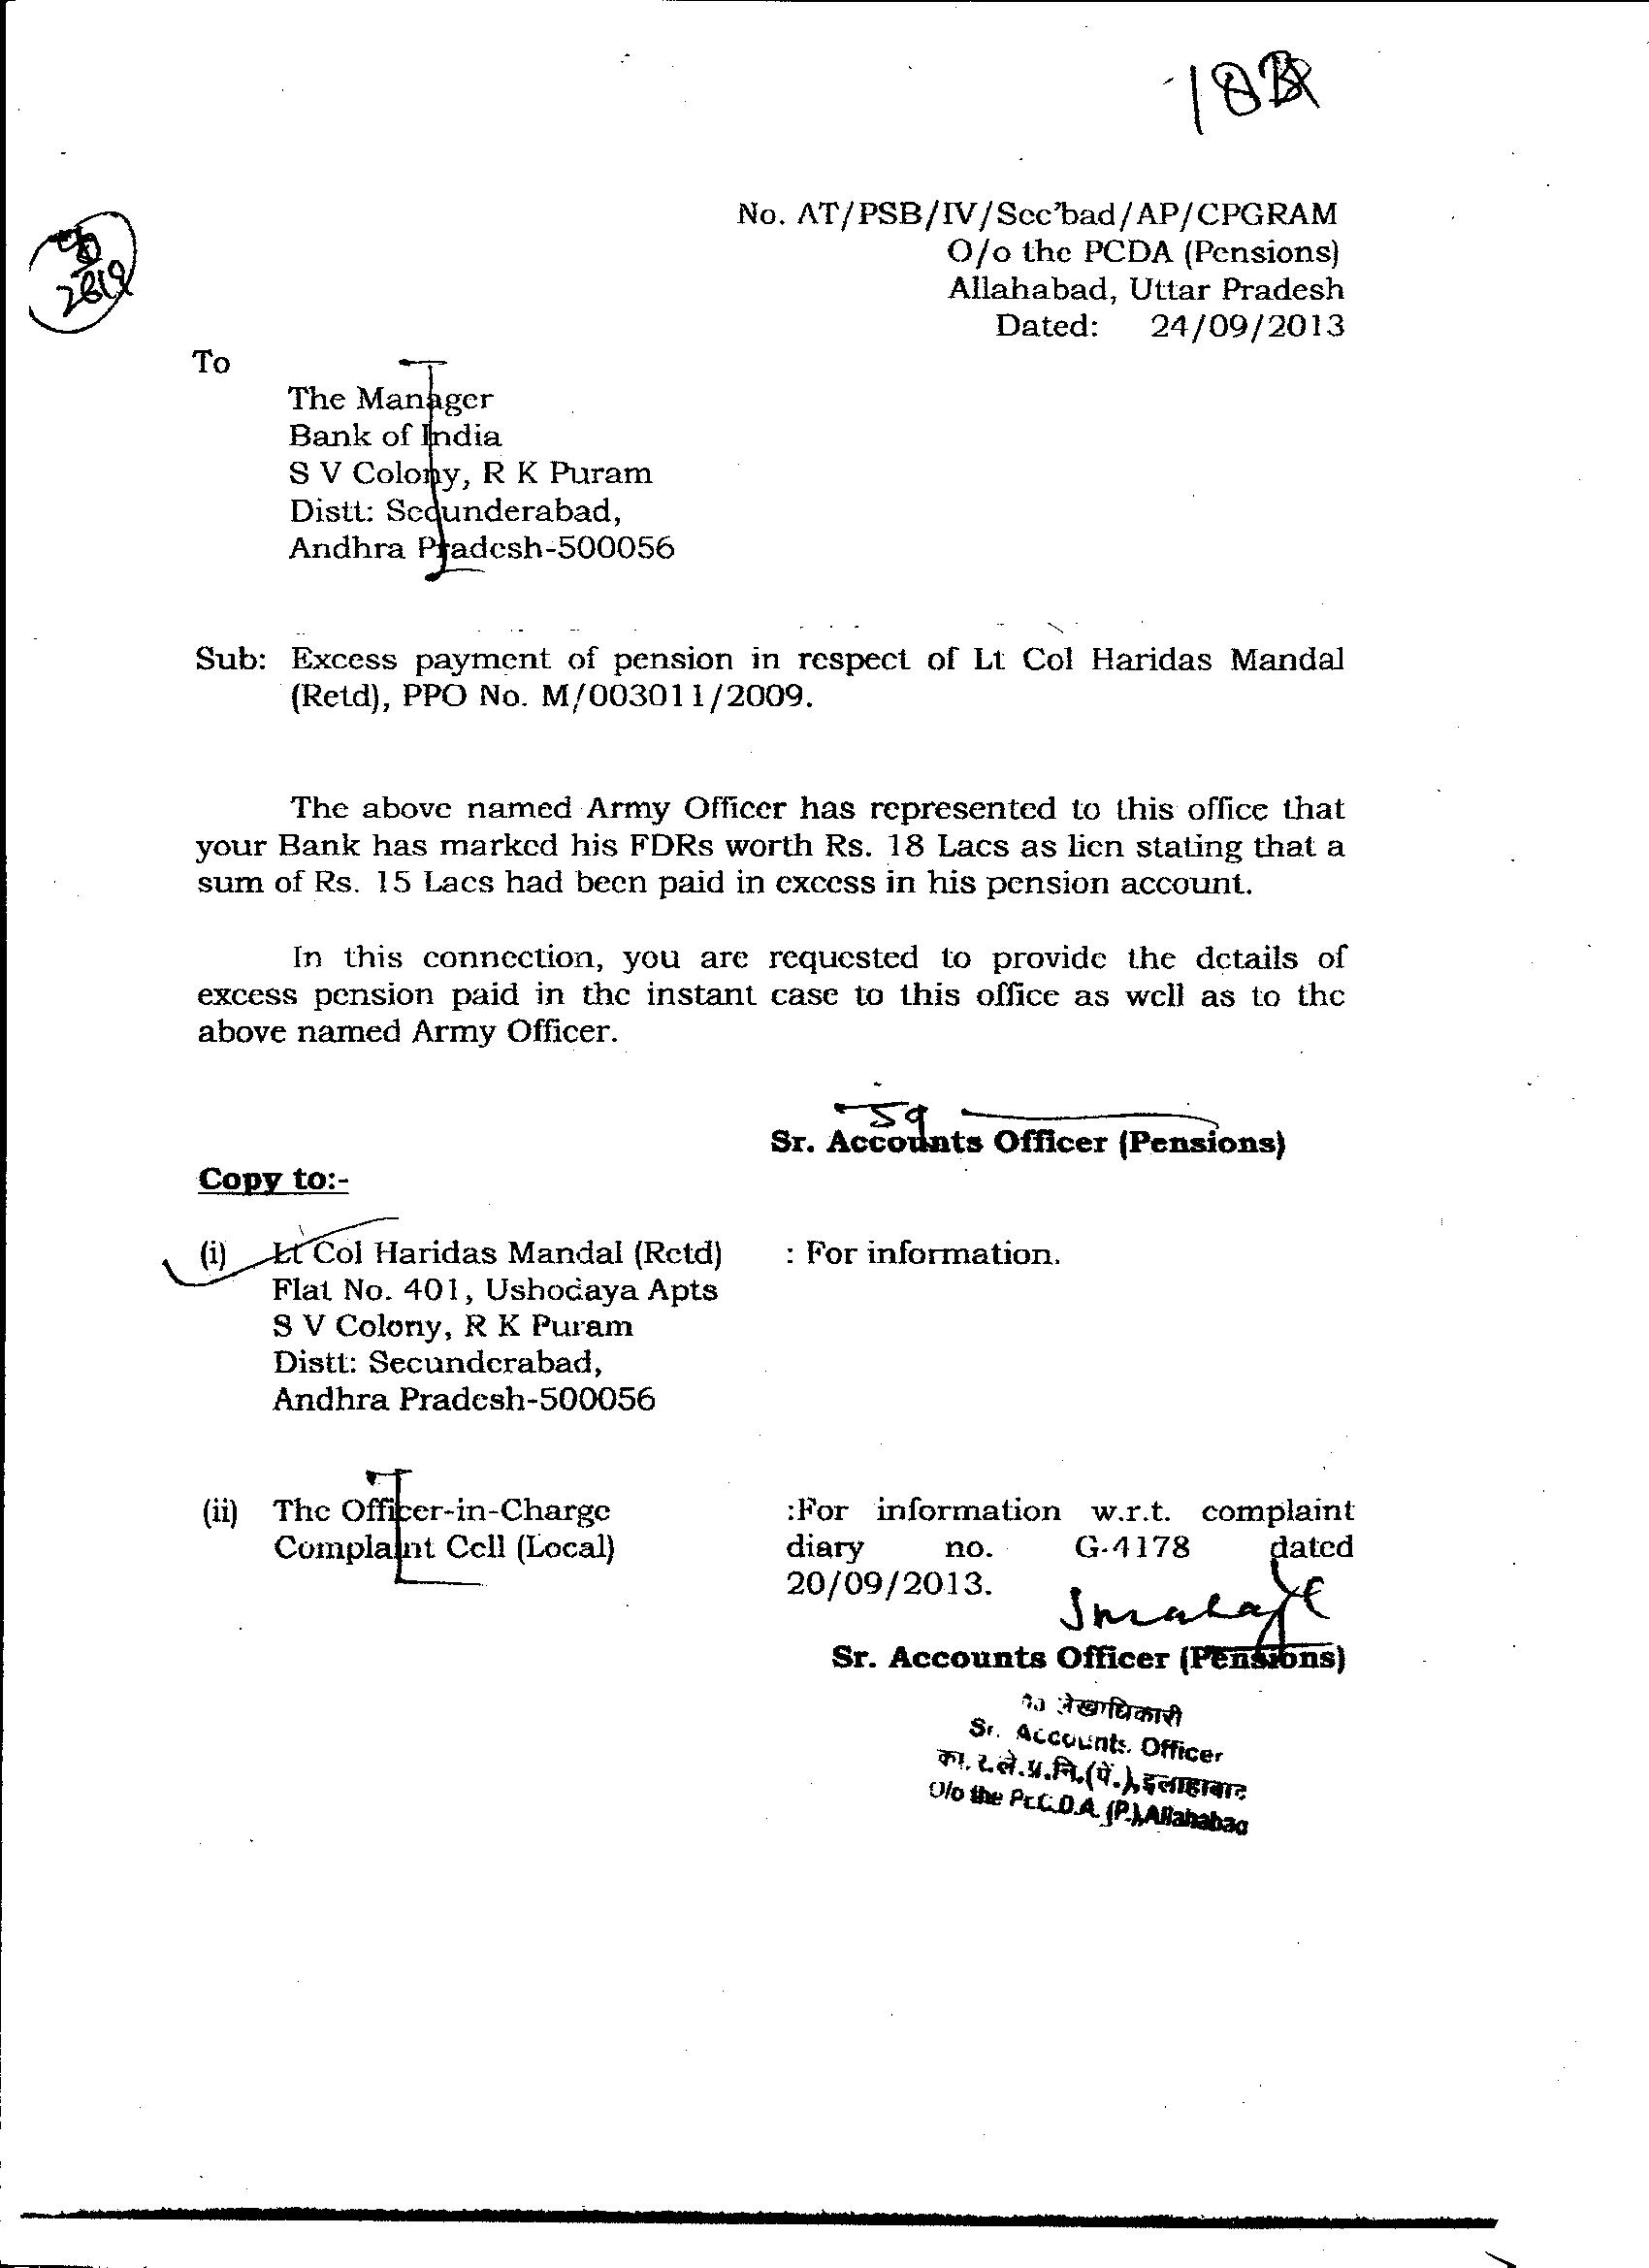
But they did not receive aninformation from the bank & asked the bank to act utgently vide their letter .
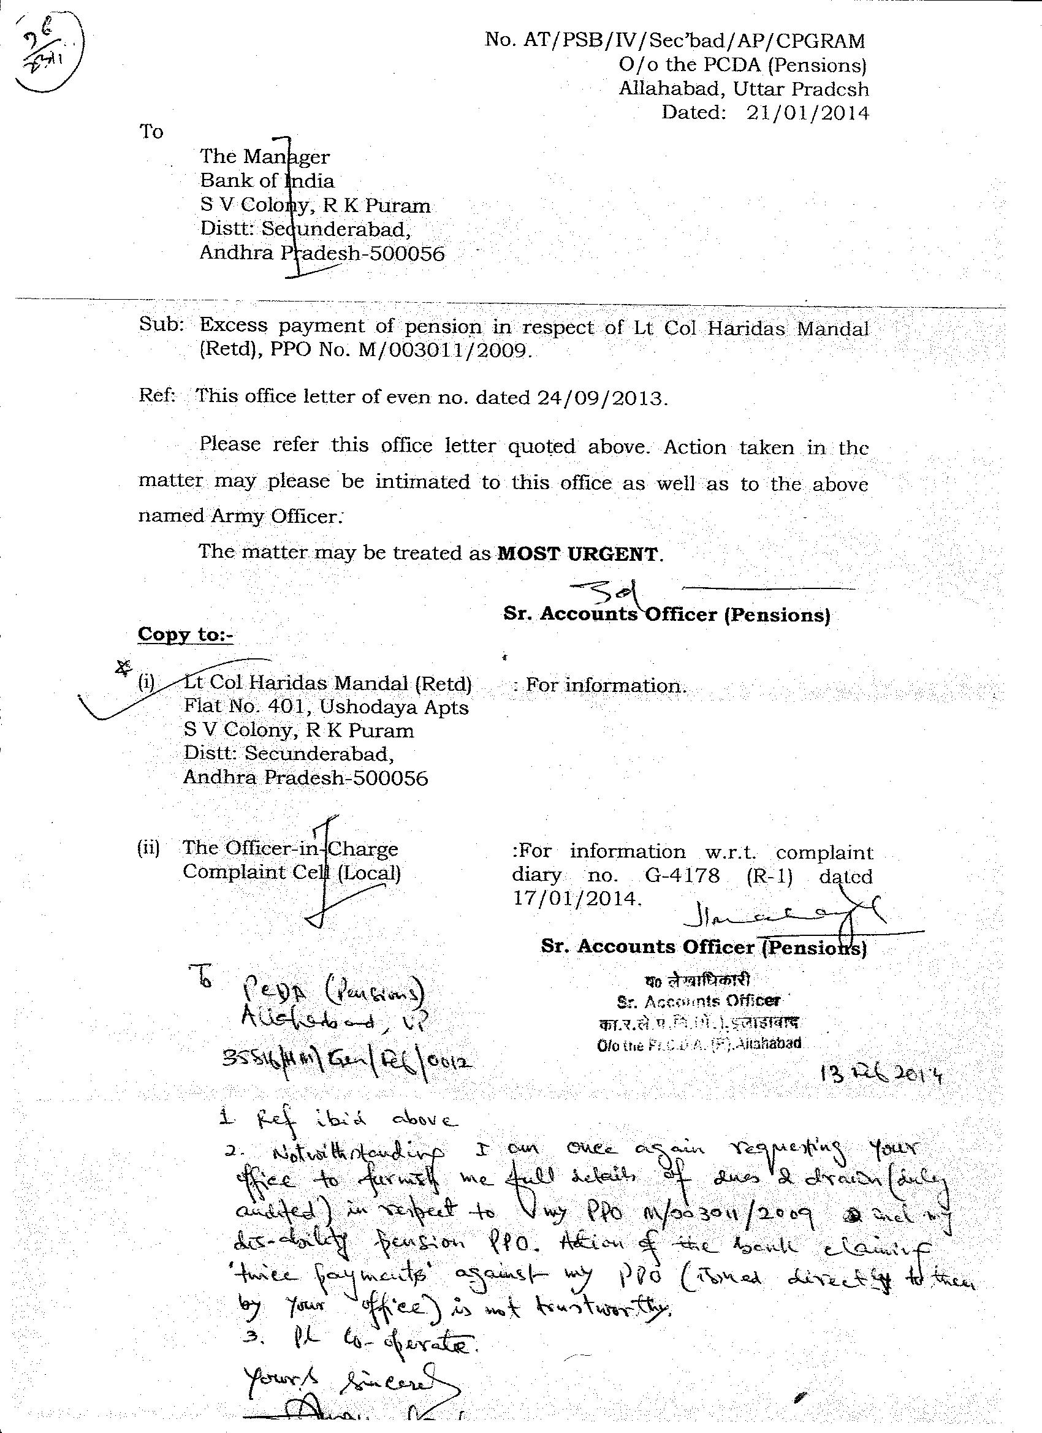
The bank replied vide their letter dated 04 Mar 2013 stating they had in fact informed them on their letter dated 17 Oct 2013…a letter may be found with the Branch Manager BOI as it is highly probable or PCDA managers are telling lies..
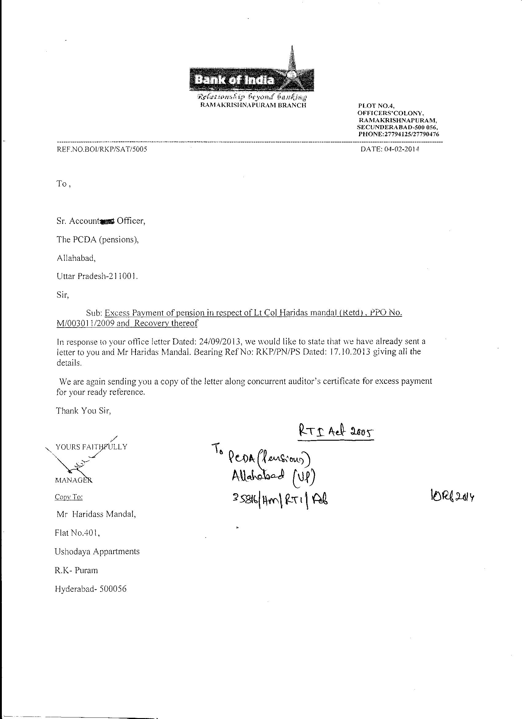
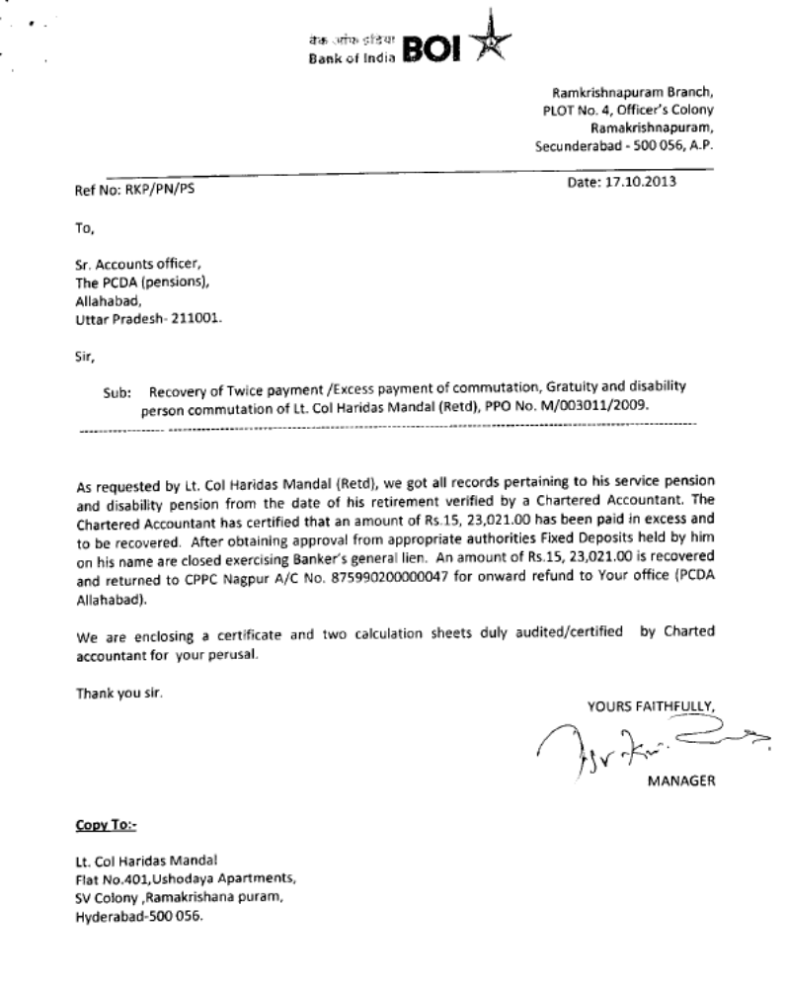

It is of immense importance here to high light how the bank concealed from the PCDA (If There was no got up) that interest component of Rs 3,84,744.00 from the FDRs had already been appropriated by the bank directly depositing the amount to their TEA Party sorry Office acct..vide their letter dated 11 Oct to me and me only..
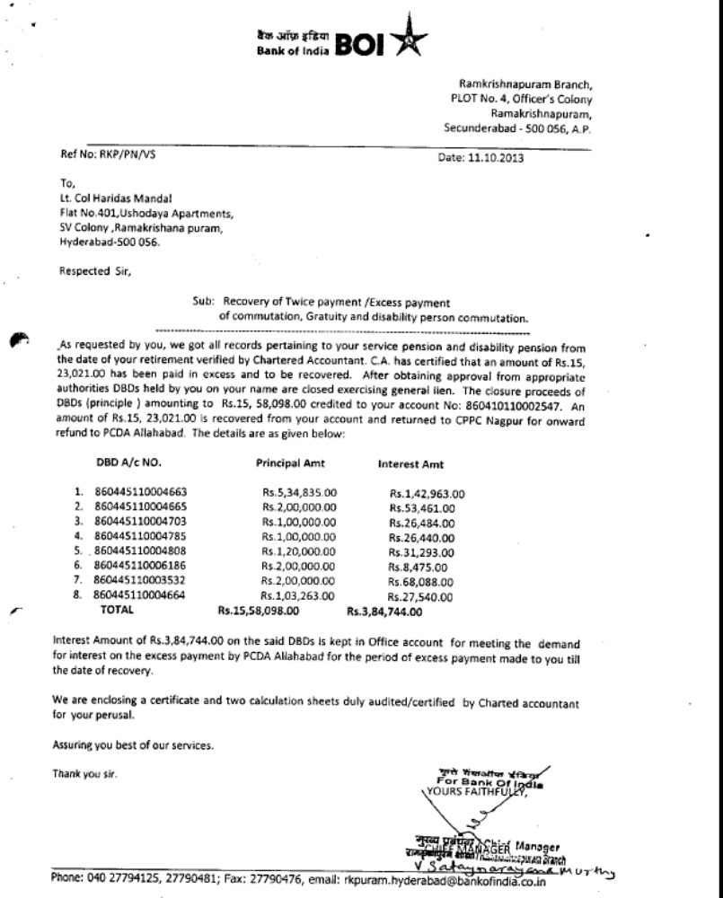

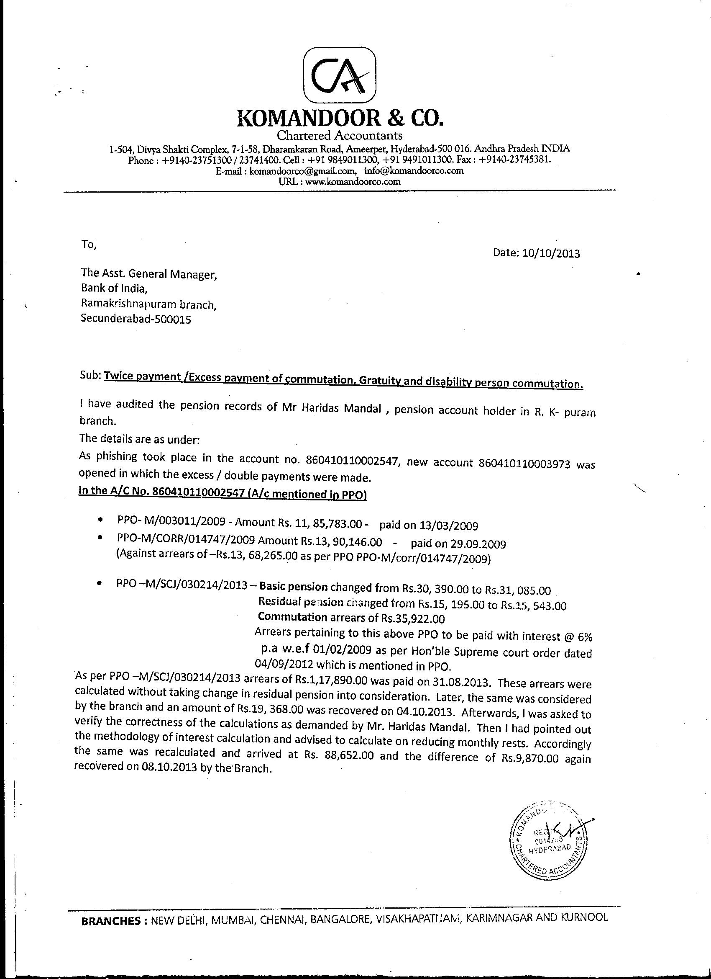
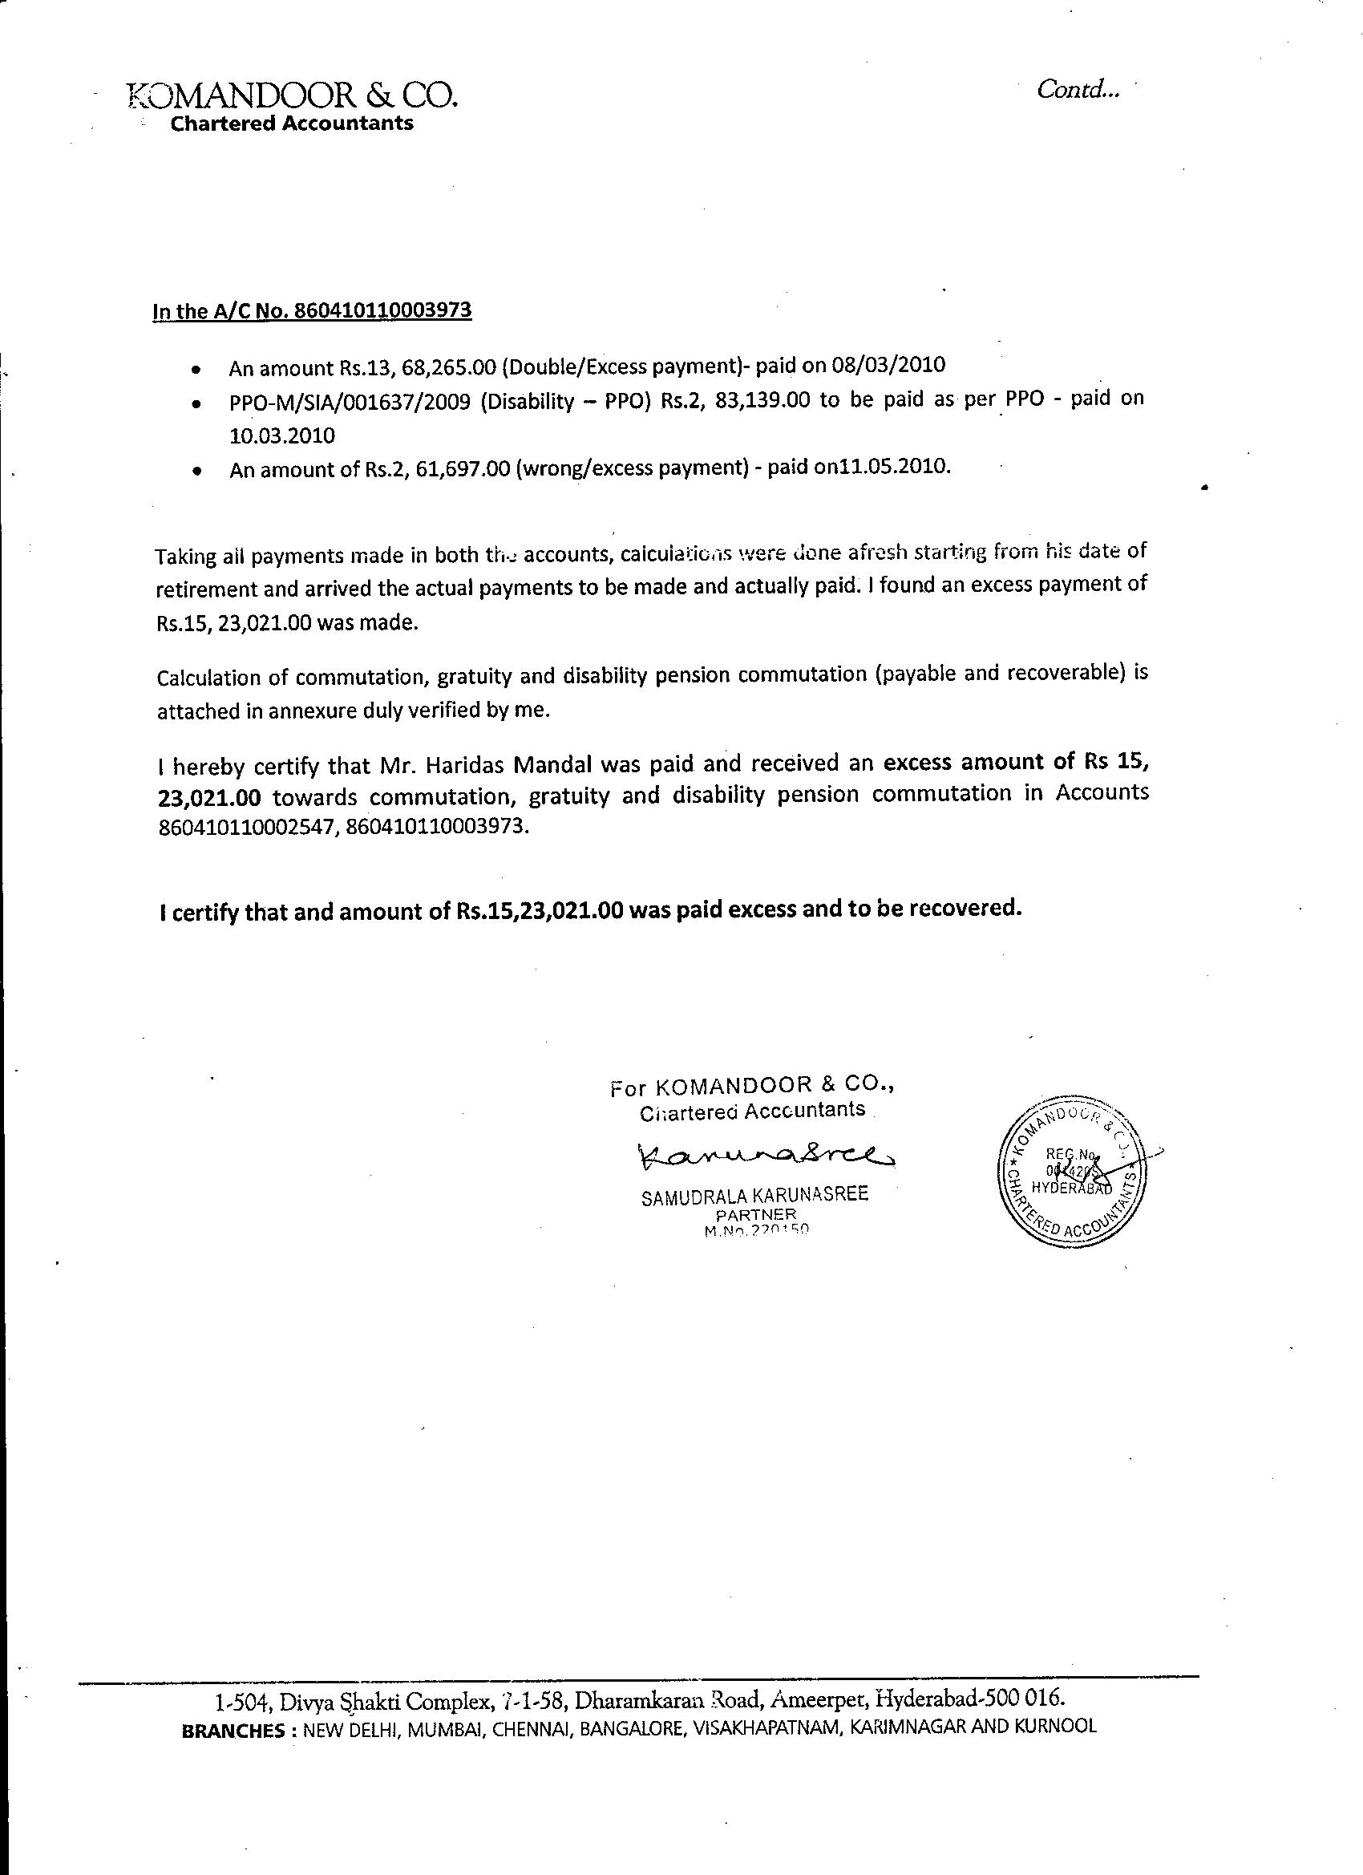
That PCDA was not impressed by the certificate issued by the bank’s private CA. It has now instructed vide their letter dated 17.04.2014 ...

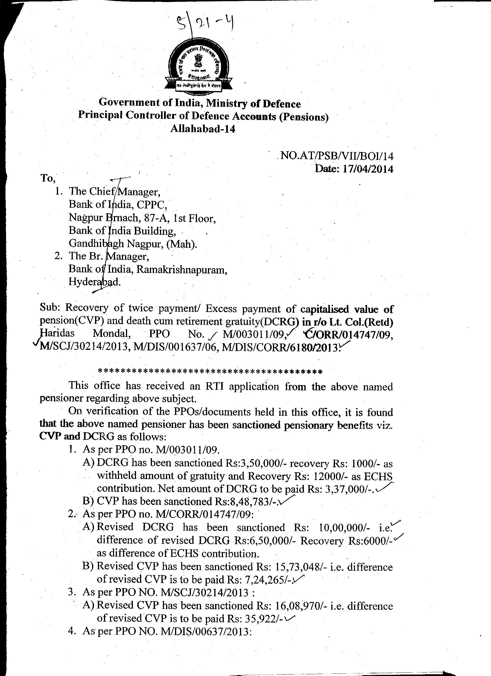

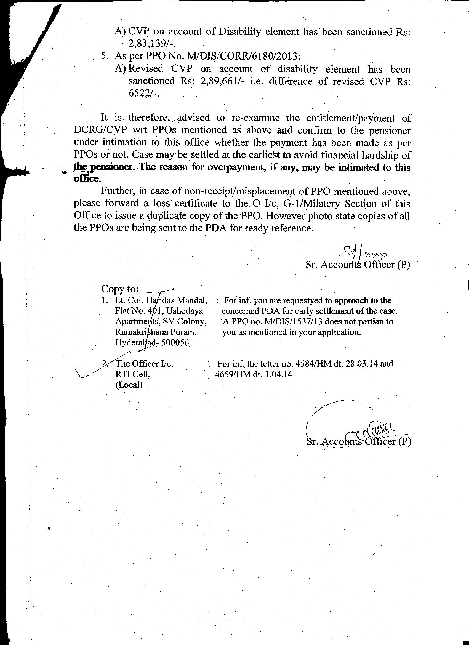
…the bank to re-examine the entitlement /payment of DCRG/CVP to me. This itself is sufficient to prove that the bank and its private CA were not accurate. The bank’s private CA did not even venture to suggest appropriating interest component to its TEA PARTY sorry Office account. Exercising banking Lien to appropriate FDRs was not at all an option available to the bank.
4.10 Para 10– “ In view of the fact ……….. we request you to close the complaint justifiably”. My Reply:-It is the PCDA ( Pensions) Allahabad which is to be intimated as it has issued the PPOs and is responsible for welfare of its defence pensioner. It has issued its direction vide their letter dated 23 .04.2014 to re-examine the entitlement/payments. The bank & its private CA have both erred in calculating the dues/paid as well.
5. Not withstanding the bank had the only option to recover even if there was an excess payment as per the provision as para 1 of the circular issued by PCDA(Pensions) Allahabad Min of Def Govt of India in 2009 to all the CMDs of all PSU/Private PDA banks clarifying the directives of the Reserve Bank of India letter No DGBA.GAD.No.H-10450/45.03.001/2008-09 to the CMDs of all PSU/Private PDA banks..
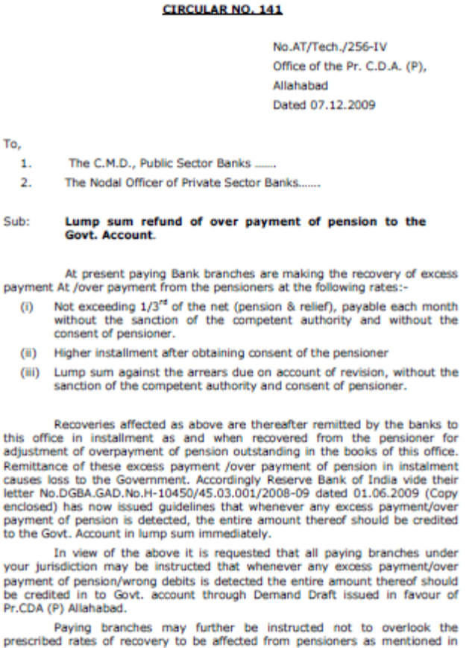
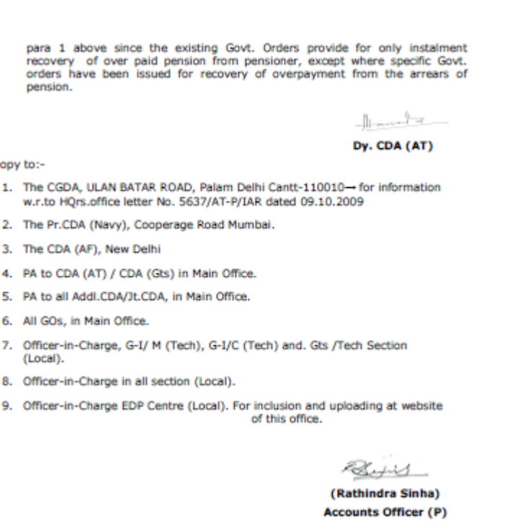
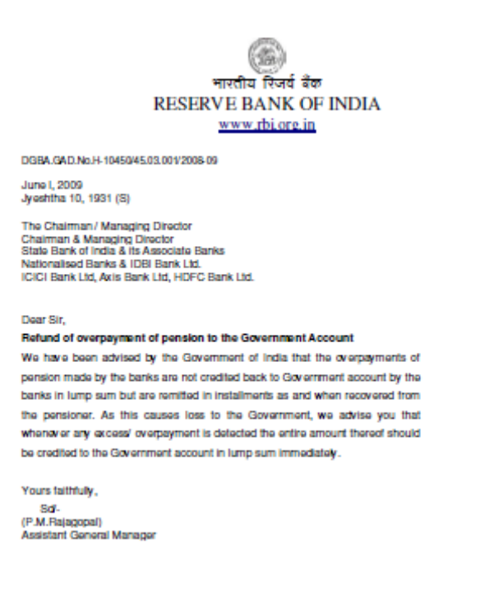
. Force closing of my FDRs with or without an approval from its ZO / controlling authority was not an option available to them. It was illegitimate on the part of the bank to appropriate my FDRs to recover alleged excess paid (with or without phishing attack, centralization of the pension accounts or one payment made by Nodal Br while other paid at the local Br notwithstanding).
5.1 That the BO was informed of their ill-legitimate action to mark my FDRs as Lien as well as well as its forced closure. Instead it disposed off my case under clause 8 &9 (3) and then under clause 13(a) only to debar me from appealing to the appellate authority. This approach of the BO indicated that he has no regard for the sanctity of the process of dispute resolution through the BOS.
6. Unsubstantiated Allegation from Bank.
6.1: That the bank contends that twice payment made to me due to phishing in my pension acct and opening of another account. It in fact unblock my pension acct at 1710hrs on 01 Jan 2010 vide their email dared 01 Jan 2010..

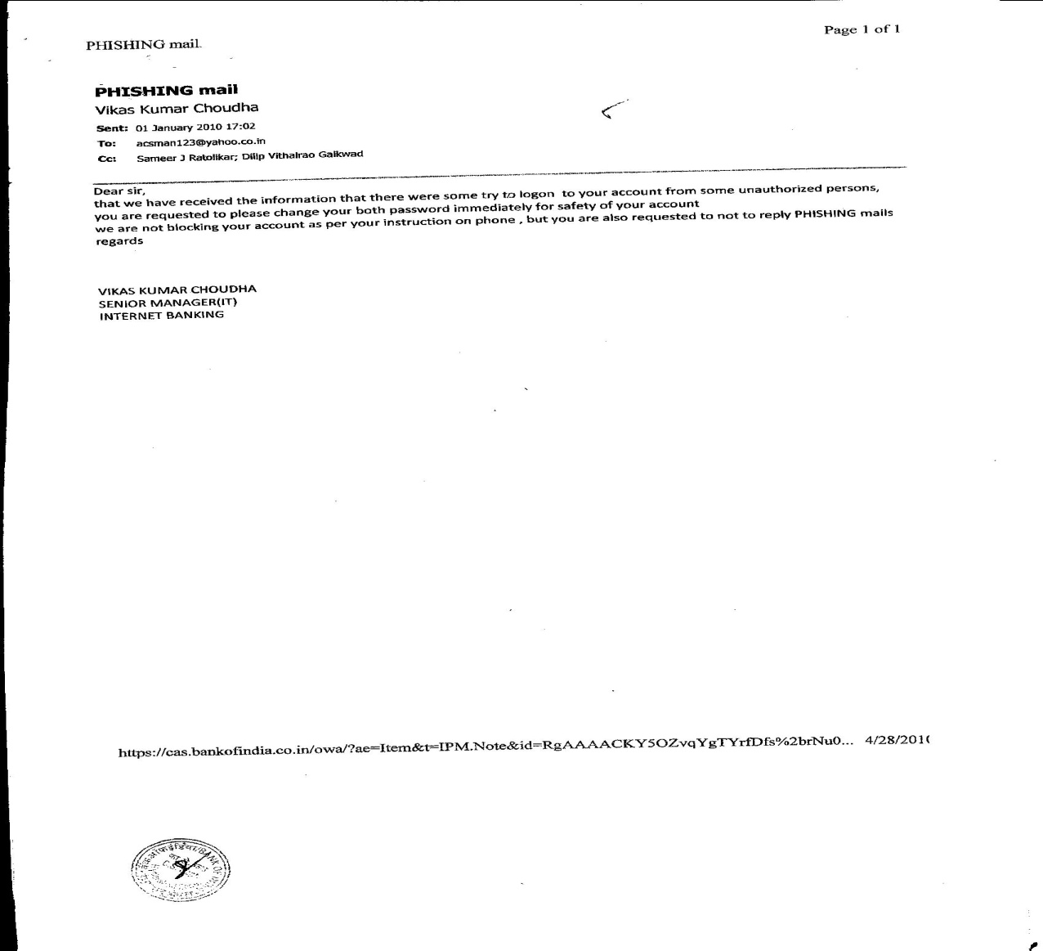
Only to allow phishing /hacking of Rs 90,000.00 from my pension account immediately after 1710 Hrs on 01 Jan 2010 giving no scope to me to view the mail and change password etc as suggested. Many head may roll if exact time for first transfer after it was unblocked is deciphered from the statement of acct below..
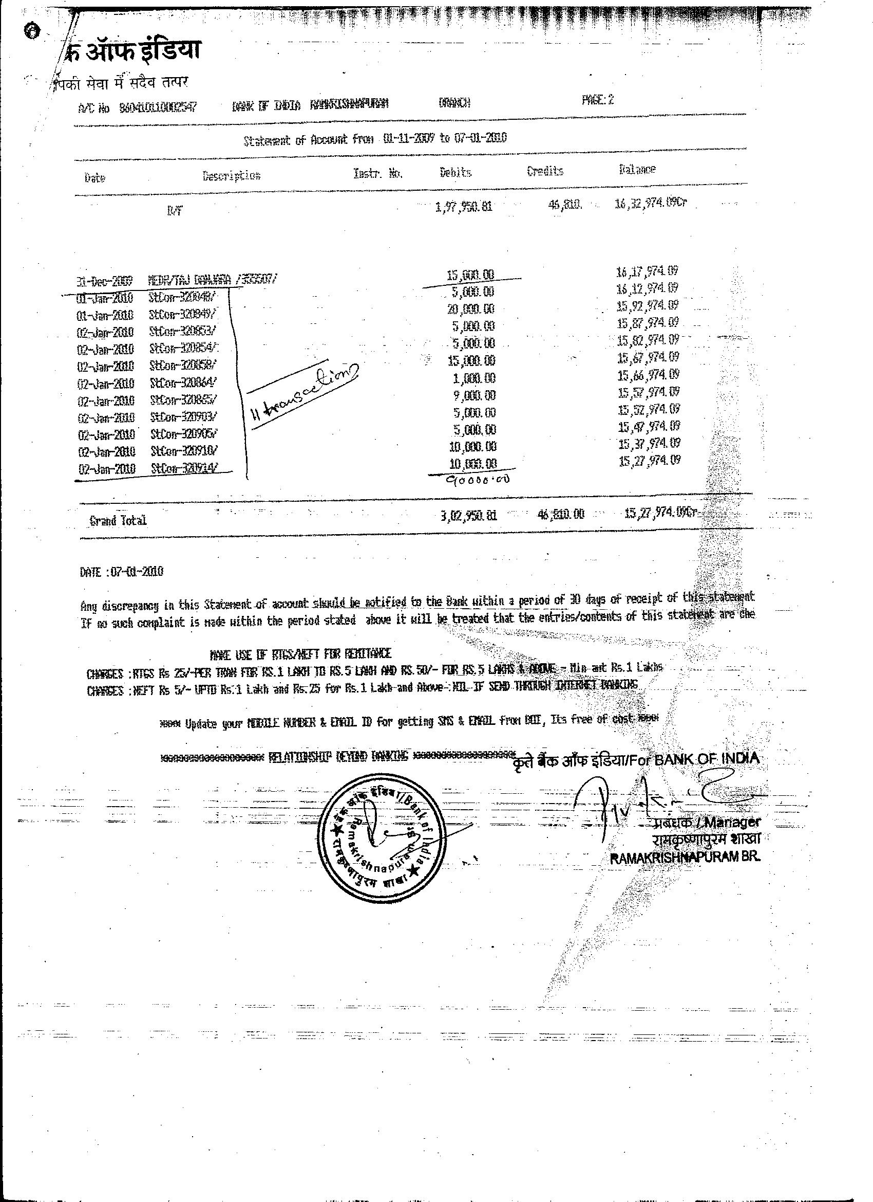
The BO simply asked for the KYC documents of the beneficiaries. They were provided to him promptly. He found no infirmities in KYC documents.
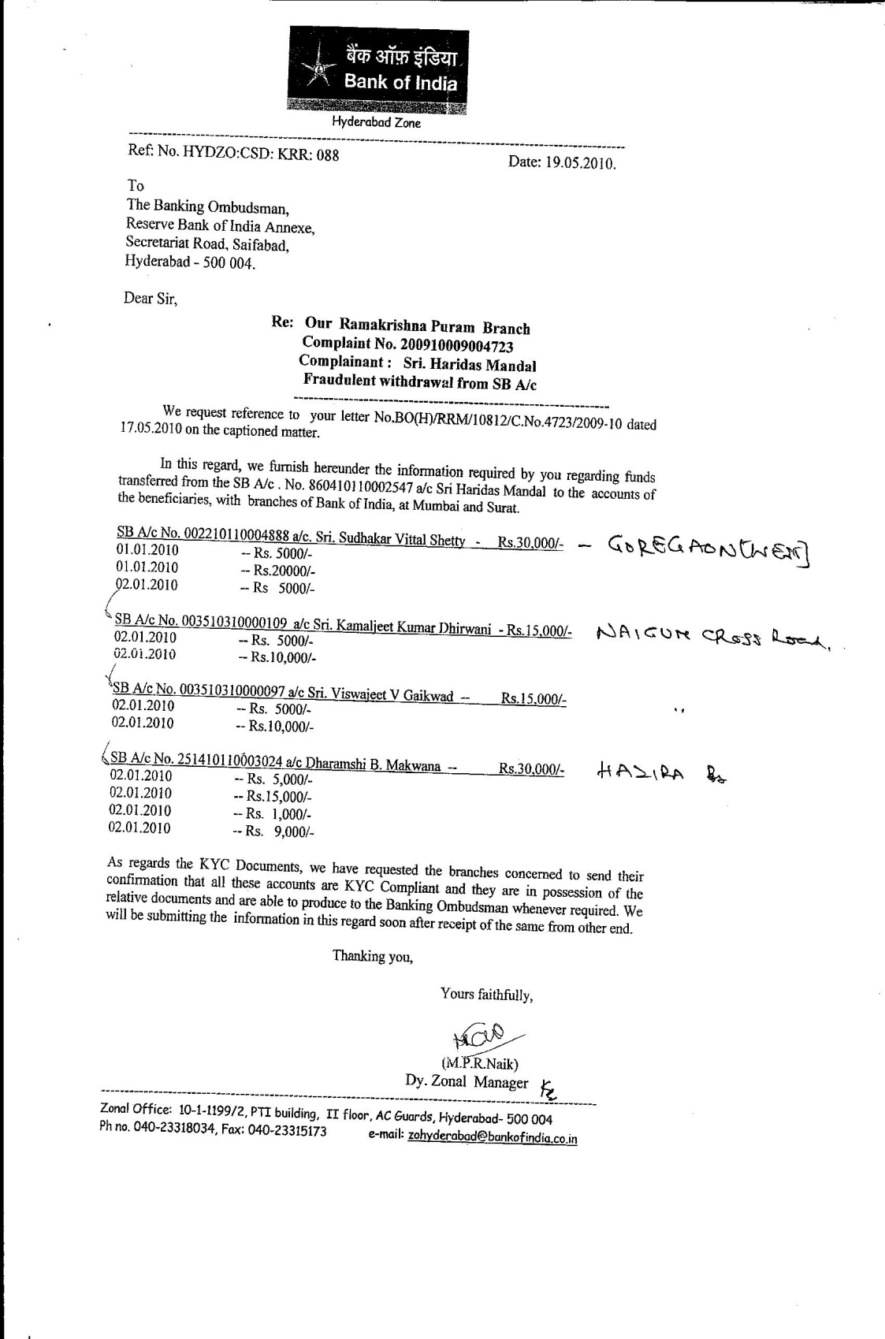

During hearing before the BO the bank retracted from their stand and blaming the customer for compromising his credentials. The BO, with all his experience & wherewithal under his disposal, with KYC documents in his hand got highly satisfied & termed them as VALID INTERNET TRANSFERS.
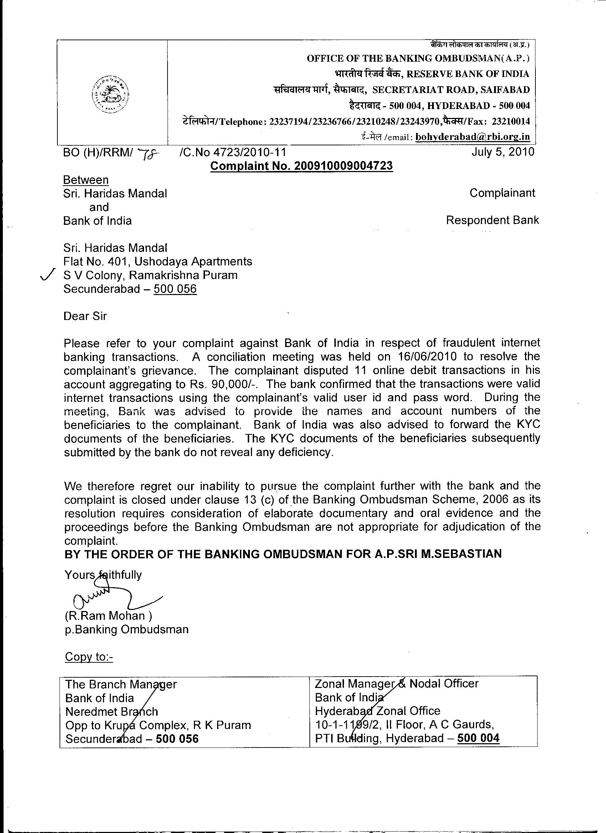
In gist the same bank which claimed that there was no phishing / hacking in my pension acct but VALID INTERNET TRANSFERS, now is taking such VALID INTERNET TRANSFERS as the main reason for excess payment.
6.2: That the Bank has attributed its mistake further to one payment made at the bank another paid from its Nodal Branch. It is absolutely scandalous as payments are made against original PDA/PDO bank’s copy of PPO sent directly to the designated office of the PDA/Bank account payable…duly endorsed once paid..
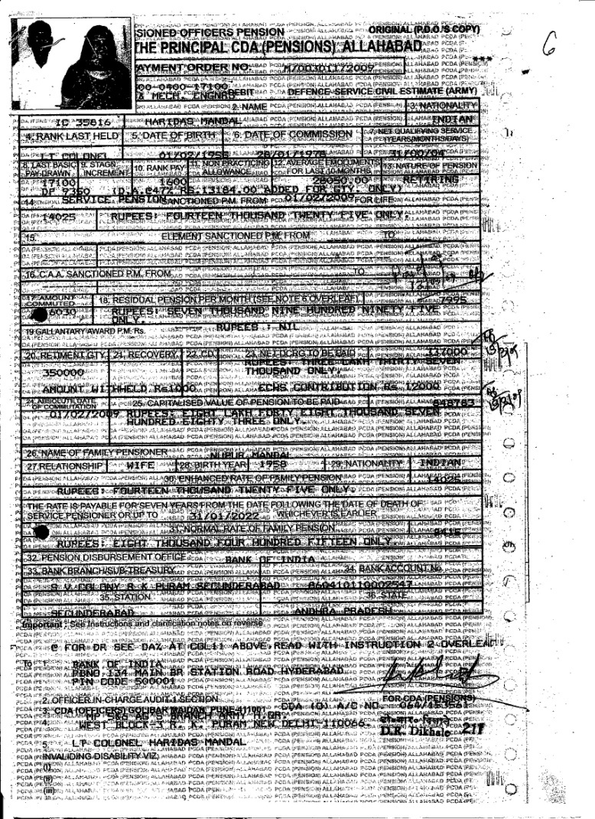

It is next to impossible to pay a sum of Rs 15 Lacs twice and forget about it for the next 4 years with a gang of highly specialized internal/external audit officials on payroll.
5.3 That the bank manager had informed the customer about alleged excess payment on 01 Aug 2013. On the same day it asked permission from its Zonal Office to exercise banker’s Lien to force close my FDRs and appropriate whole amount far in excess to the alleged excess made.
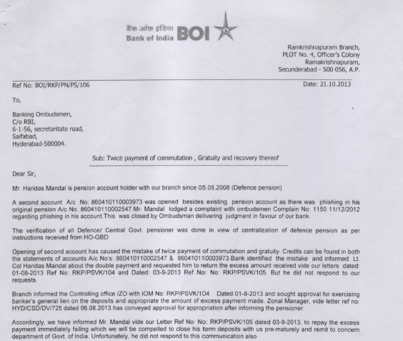
It is now proved beyond doubt that the branch manager, the controlling auth/ZO & the CPPC Nagpur were in collusion. Not obtaining permission of PCDA, engaging a private CA of ill-repute and then retaining interest component to their office Tea Party acct was in fact was done as a part of their grand strategy.
Omissions by the BO:-
6.1: That my complaint to the BO was registered on 15 Oct 2013 & I was informed only on 18 Oct 2013. The BO has invoked the provision of clause 11 of the BO Rules 2006 as amended to obtain their reply. The bank had submitted its reply presumably on 23 Oct 2013.
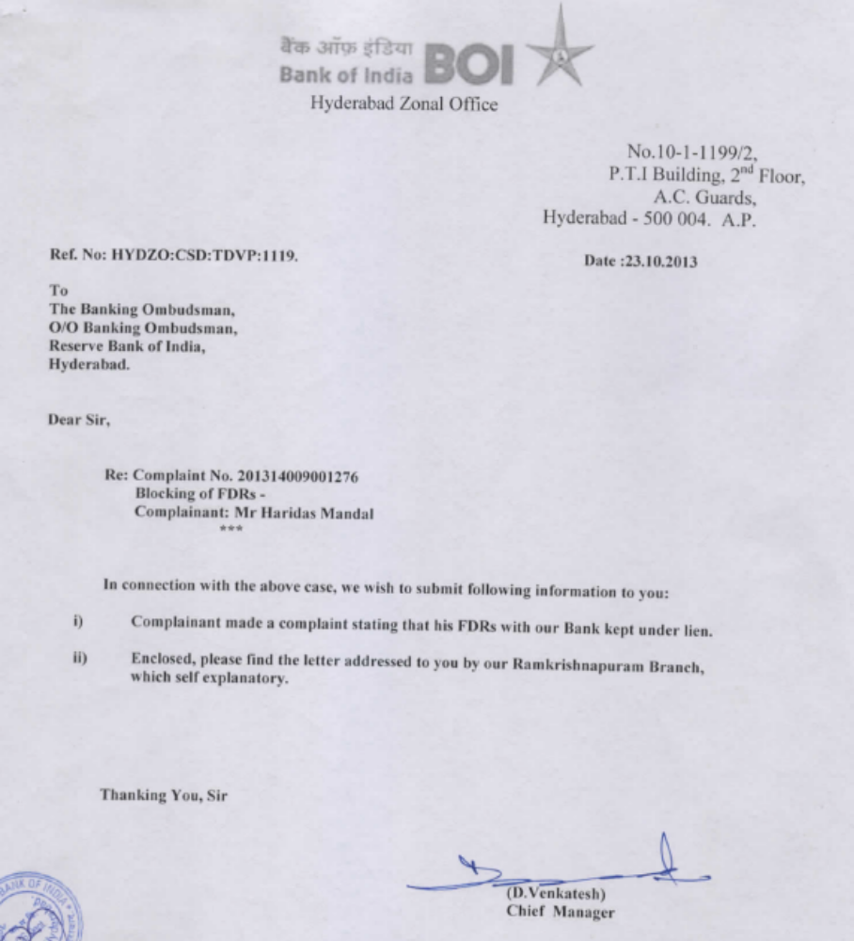
The BO supposedly disposed of my complaint under clause 8 & 9(3)..
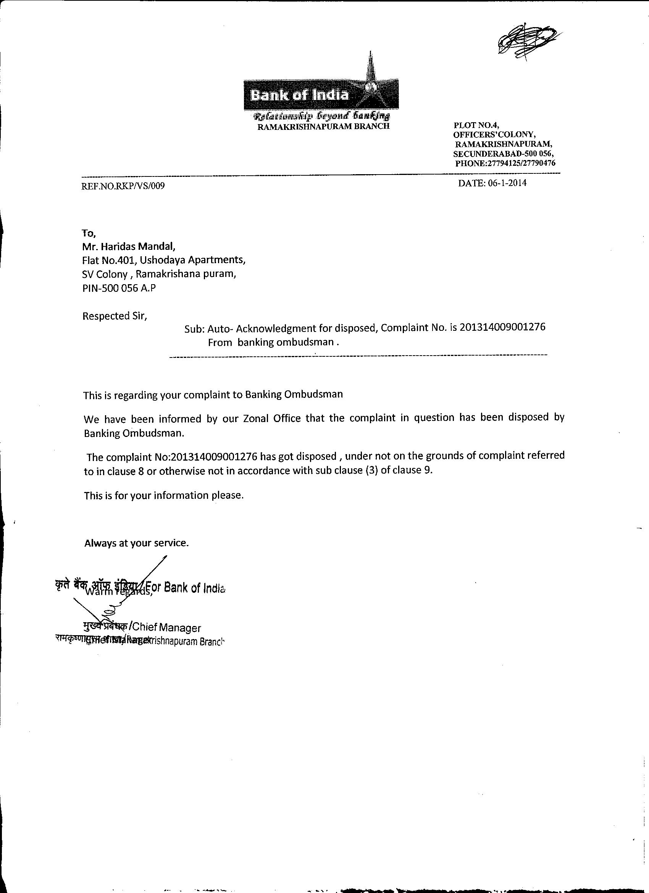
. The BO informed the bank but chose to with hold the order from the complaint till the complainant submitted his complaint afresh on 14 Mar 2014.
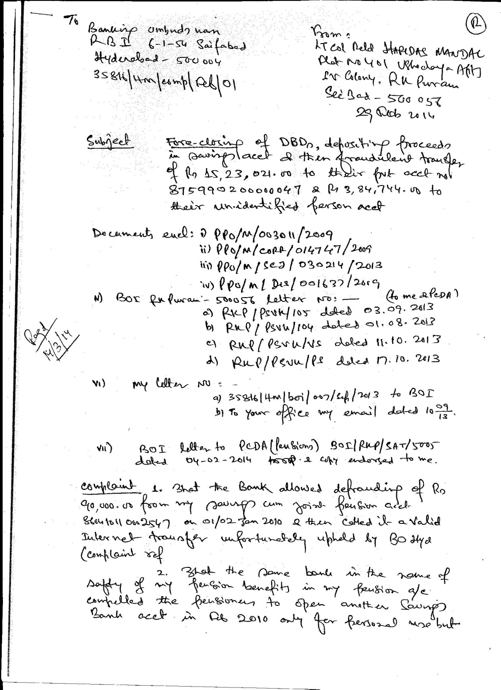
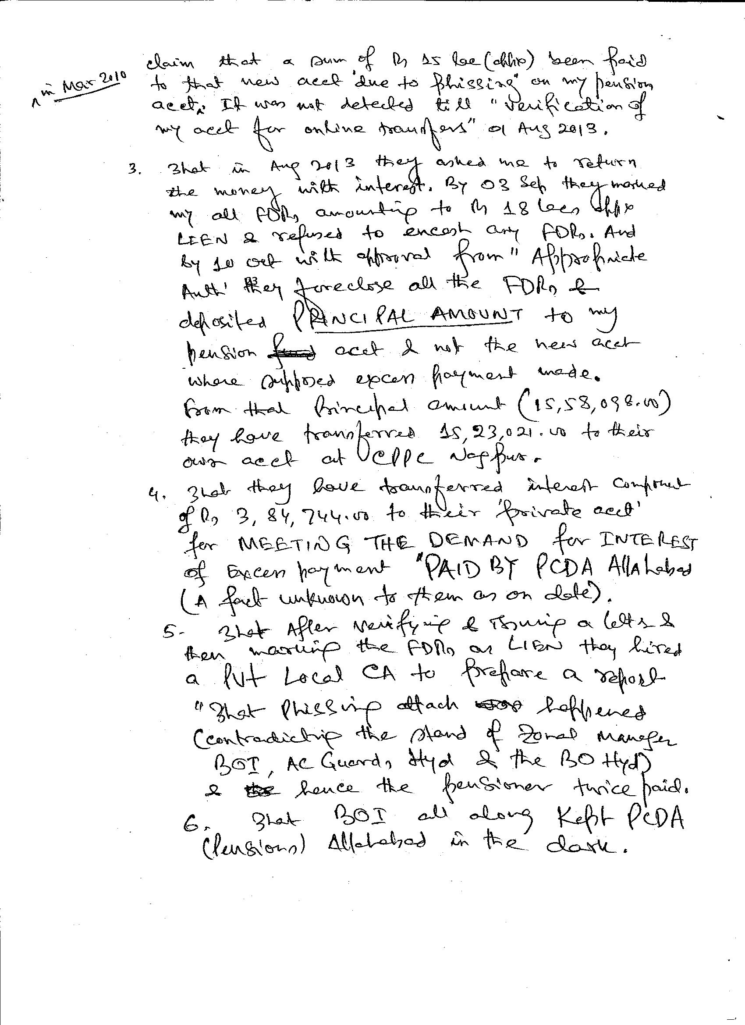
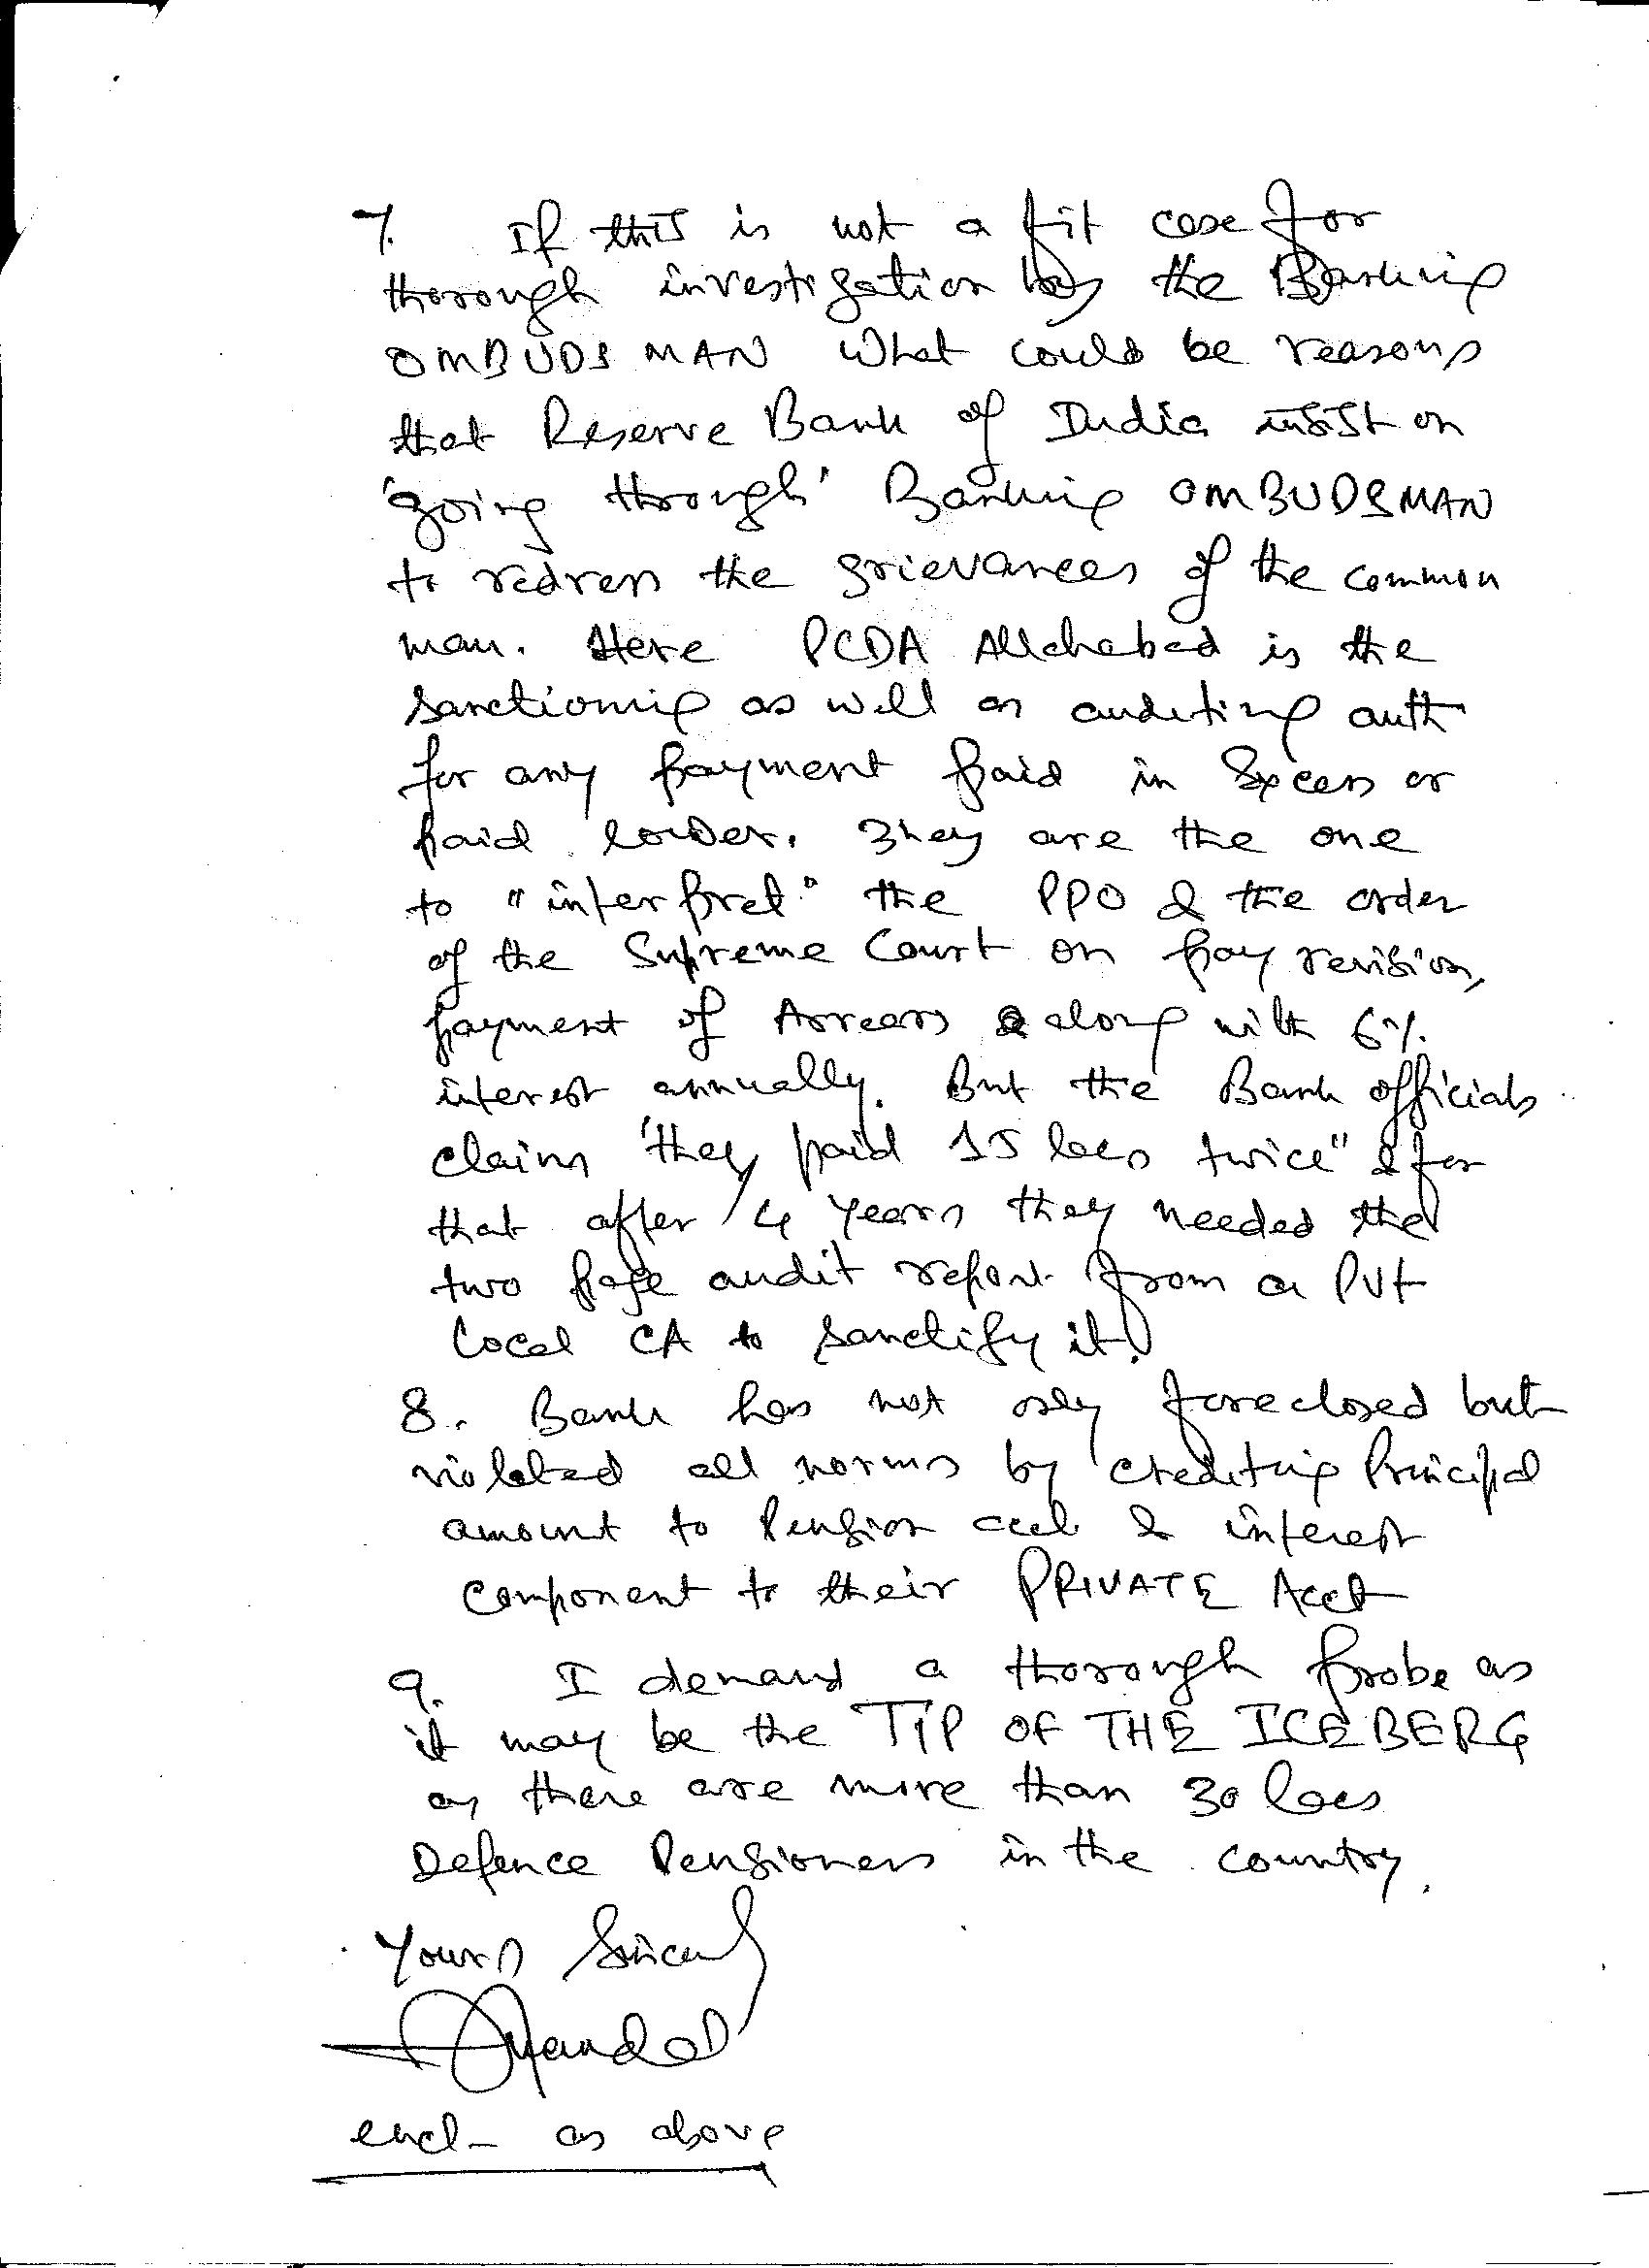
The BO did not ack receipt of my complaint dated 14 Mar but chose to dispose the earlier complaint again under clause 13(a) instead of clause 13(f) being the most appropriate.
6.2 That the Banking Ombudsman failed to see the obvious contradictions and his contention that “There is no deficiency of service” is an untenable excuse to unfairly disfavor the complainant. By taking a contrarian view without any justification, the BO has demonstrated his bias that “Bank is always right” whereas the Indian Banking system respects the saying “Customer is always right”.
7. Other Omissions by the BO:
7.1: That the BO had all the relevant documents held in its office in respect to its order on complaint No 200910009004723 terming all the transactions as VALID INTERNET TRANSFERS to absolve the same bank from its obligation on hacking of Rs 90,000.00 from my acct. It wouldn’t have allowed the bank to get away with such contradictory stand.
7.2 : That the BO has not considered it necessary to ask a question as to why the Bank failed to inform the PCDA or why it failed to comply with the provision as at circular No 141 issued by the PCDA even if in their view there was an over payment in the year 2010 but detected only in the year 2013?
7.3: That it was expected of the BO to ask what was the hurry in obtaining approval from the Zonal Manager to appropriate FDRs even before the defense pensioner reacted to the letter dated 01 Aug 2013? Further the BO has shown no inclination to try and understand the problem posed by the customer and blindly given his verdict unilaterally with utter disregard to the customer’s version of the incident.
7.4 : That from the letter of PCDA to the bank dated 17 Apr 2014 it is amply clear that even the calculation by the bank & its private CA to conclude over payment of the tune of Rs 15 Lacs was wrong. The BO was expected to recheck or simply refer the matter to the PCDA, being the competent auth in defence pension matters. It had done none.
7.5: That Banker’s Lien on FDRs is itself a much disputed instrument to allow the bank in such circumstances to force close & appropriate all my FDRs to recover excess payment made especially to a defence pensioner. It chose to feign ignorance on the issue of appropriation of interest component over & above directly to the bank’s TEA PARTY sorry Office accounts PCDA duly kept in the dark.The BO was expected to be aware of the provision of Circular No 141 as well. It had acted too bank friendly.
8. In view of the above, we request you to kindly over rule the BO’s order and direct Bank of India to immediately restore the status of all my FDRs along with a reasonable compensation for the loss of interest as well as the unjustified harassment to which the Customer has been subjected to.
9. Further the issue of excess payment if any must be dis-associated from the issue of appropriating all my FDRs. The bank is at a liberty to approach the PCDA Allahabad to tackle the issue of recovery of the alleged over payment if any or else strictly follow the provision as at Circular No 141 issued by PCDA till the PCDA (Pensions) Allahabad comes out with its authenticated version of dues /drawn statement. As the bank has mentioned phishing attack in my pension acct leading to opening of a new savings acct as one of the reasons for their silly mistake on alleged over payment in another account (other than the acct payable) it must ask BO to investigate the matter further as such action might have been replicated for other defence pensioners as well. In fact it should be replicated for all PDA PSU/Private banks for defence pensioners as they seem to be the easy prey for the banks to black money, generate enough interests , detect it and then appropriate the interest component to their respective TEA PARTY office acct.
10. While making this appeal we would like to state that this is still a mediation effort
Being invoked under the BOS and in the event the BO’s unfair order is upheld by the
Appellate authority, we reserve our right to move appropriate judicial forums to raise
the incident as a Crime committed due to negligence of Bank officials, a deficient technical system of auditing, failure of Banking supervision by the regulatory body and seek appropriate civil and criminal liabilities to be pressed against the Banks.

Thanking you

Yours sincerely

Lt Col Retd Haridas Mandal
Flat No 401 Ushodaya Apts
SV Colony, RK Puram
Secunderbad-500056

