How to scan a document and convert it to a Word document

Getting Started
Before you begin this process be sure to have your documents ready, a computer with Adobe
Acrobat Professional 7, and a scanner.

1. Place your document onto the scanner
2. Open Adobe Acrobat Pro 7

Preparing and Scanning your Document
Before you are able to scan your documents you must configure the software with the settings
provided below.

3. From the File menu select Create PDF > From Scanner

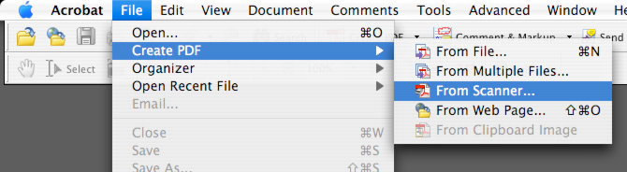

4. From the Create PDF from Scanner window, click on the Scanner drop down menu and select your scanner (For this example we used an Epson Perfection 2400)

If your scanner does not show up be sure it is connected, turned on, and that the drivers have been installed.
☞

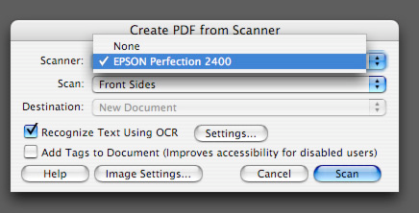

1
For assistance with this process contact the
poets@sfsu.edu • 415-338-7638

How to scan a document and convert it to a Word document

5. From the Scan menu select:
a. Front Sides for single sided documents or
b. Both Sides for double sided documents

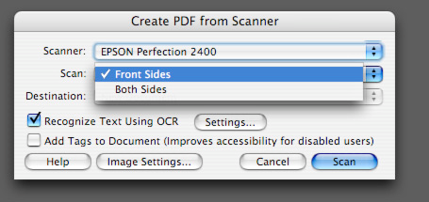

6. From the Destination menu select:
a. New Document to start a new document or
b. Append to Current Document to add pages to a current document (document must be open)

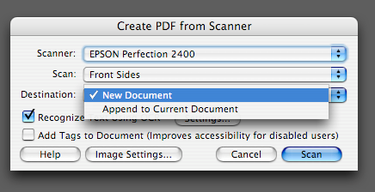

7. Make sure the Recognize Text Using OCR box is checked and click on the
Settings button.

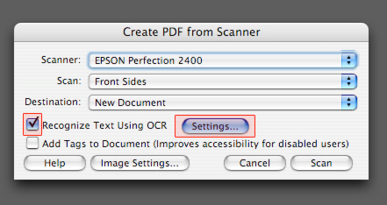

2
For assistance with this process contact the
poets@sfsu.edu • 415-338-7638

How to scan a document and convert it to a Word document

8. Select Formatted Text & Graphics from the PDF Output Style menu in the Recognize
Text – Settings window and click OK.

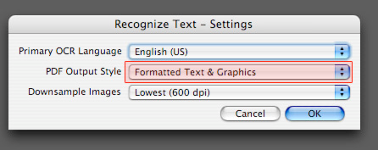

9. Once you have finished adjusting the settings click Scan.

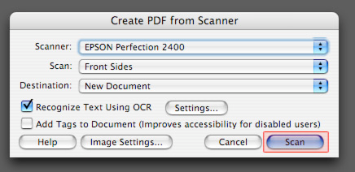

10. After the scanner has completed scanning the first page a dialog box will appear asking for the next page.
a. For a single page click Done
b. For documents with multiple pages click Next
a. When the last page is finished scanning click Done.

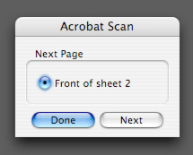
.

3
For assistance with this process contact the
poets@sfsu.edu • 415-338-7638

How to scan a document and convert it to a Word document

Converting the Document
Once have scanned the document you can then save the file as a Microsoft Word document; this will format the file similar to the way it appeared. It may be necessary to correct some formatting issues.

11. After you have finished scanning, from the File menu select Save As
12. In the Save As field enter the name of your document. We have entered test
13. Select the save location. (The default is your Documents folder)
14. From the Format menu select Microsoft Word Document

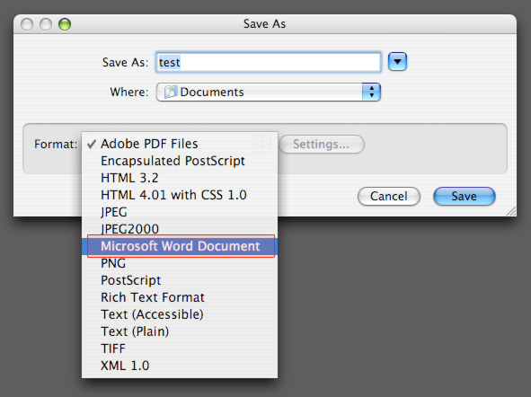

15. Click the Settings… button
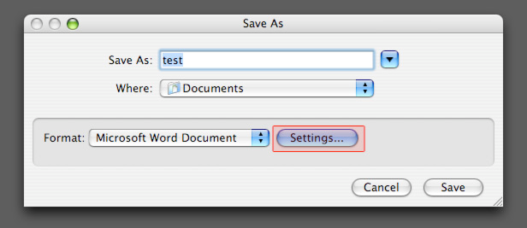

4
For assistance with this process contact the
poets@sfsu.edu • 415-338-7638

How to scan a document and convert it to a Word document

16. From the Save As DOC Settings window uncheck Include Images and click OK.

This prevents any dark spots, lines, or any other imperfections created in the scan from being converted into embedded images in your document. If your document does have images that you want preserved in your final document it is best to scan those separately and add them to the final document.
☞

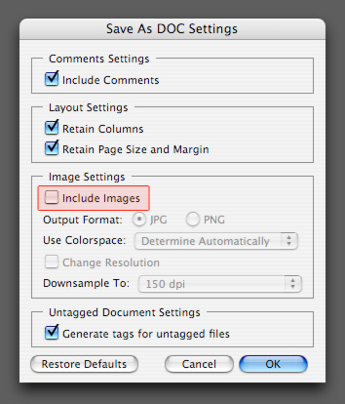

17. Click Save

5
For assistance with this process contact the
poets@sfsu.edu • 415-

