Domestic Violence during Pandemic Times

Submitted by
SALONI SHARMA

On
16th August, 2020

The humanity is going through a huge coronavirus catastrophe which has slowly and steadily taken over all nations be it developed, developing or under developed. Masses are dead and a greater number are infected by the deadly virus. Authorities are opting different strategies to cease the virus and are taking measures to lessen its impacts. The Pandemic is very aptly referred to as the Shadow Pandemic by the United Nations due to its ability to bring several other problems with it. The virus and the illness are only those problems which are imminently visible to us. Along with this it brews issues like death due to starvation, Domestic Violence, Depression, Financial insecurities and many different unprecedented challenges. The world currently is in an extirpated yet reparable state. The pandemic has claimed nearly around 771,000 lives and is determined to take more, rather not by virus but by external factors as mentioned above. The virus has attacked the country in every possible way it could, be it health and welfare, economy and employment, women and social welfare, agriculture, textile, hospitality or any other industry.
Statistically, between the time periods March 25-May 31 recorded more complaints than those received between March and May in the last 10 years. Surprisingly, during the period of Lockdown the number of cases registered between March 23 and April 16 nearly doubled with a total of 587 complaints registered. Around 1000-1200 distress calls were received by the National Commission for women every day. It is a very daunting situation as we all are aware of the fact that the number of cases reported of domestic violence are nearly a grain in a haystack. Experts, researchers and NGO’s are worried that when an actual reality check would be conducted after the lockdown, the results would be alarming.
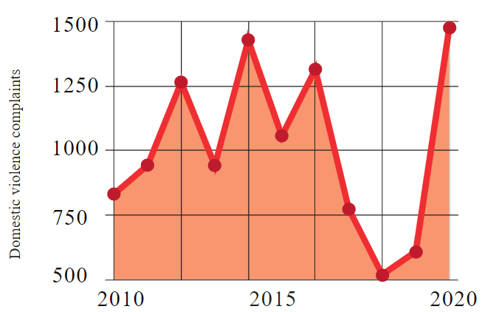
Source: National Commission for Women
The government currently is worried about the need to provide basic amenities like food, water and shelter to its people, it hardly has any time to cater attention to issues like Domestic Violence. Although it is trying its best efforts to provide mental and physical support to a much greater extent as far as possible. The woman who is a victim to such brutal acts of violence is in a very grim situation as she is deprived of medical care in such times of a pandemic as the hospitals are over-burdened and pre-occupied with COVID 19 patients.
Studies show that 70% of the Male population have access to mobile phones in India, on the contrary, only 38% of the female population has access to mobiles. Thus reporting of Domestic Violence cases via telephone calls by the victim is becoming more and more difficult. Many women in the rural areas are rarely aware about the Domestic Violence helpline numbers. Further, the pandemic worsened the situation as the woman cannot step out to call for help and support. If they did, they were attacked by the police, who asked them to stay at home. Ironically, threat looms for women where they are supposedly presumed the safest- their HOME. There also is an increased burden on women as every family member is at home which adds up to the pressure even more. The household chores have increased and with such emotional and physical abuses it becomes mentally and physically exhausting. In addition, even if a case occurs and is reported it is a tedious task for any protection officer to reach to the victim in middle of such a crisis where stepping out is a life risking task. Many NGO’s offer help in providing assistance to the Domestic Violence victims but appropriate distance, hygiene and numerous other factors have to be kept in mind while communicating. Secondly it is also very difficult for the aggrieved person to meet the protection officer as the abuser can cause further more trouble. The shelter homes have also refused to take more people due to COVID 19 crisis. 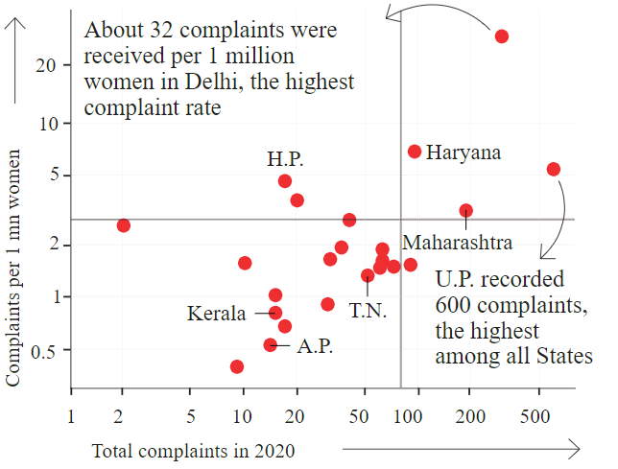
Source: National Commission for Women
Besides, women do not want their husbands to be arrested as they will soon get themselves a bail and cause more inconvenience and disturbance to the family members. One thing is certain that Domestic Violence is rooted in power and control, women being more a victim of these cases makes it crystal clear to us about significance of a woman in the modern times. Sheer socio-economic inequalities will greatly jeopardize groups of female population who already are victim to this abuse. United Nations call it to be one of the worst after effect of the corona virus as huge number of workers would be laid off from their respective jobs, thus, leading to vexation. Financial crisis is one of the reasons which causes such frustration in men. Since they cannot shout, howl and scream on their bosses they do it to their family members. Well this portrays perfect example of Patriarchy and Nuance Sexism in our society, which still persists. Sadly, women cannot leave their partners as majority of them are financially dependent on them and they also cannot seek refuge at their parents place as either they are elderly people (seeking refuge with them will put their lives at risk due to COVID 19) or there are travel restrictions. Further, the world economy is moving towards recession; No job adds up to no money which leads to financial dependence on their partners. Thus, staying at the abusers house is probably the only option left to the women.
This heinous crime is not just restricted to India but such horrible circumstances have occurred overseas as well. According to an April 15 report there has been a 30% surge of cases in France, 18% surge of cases in Spain, 30% surge of cases in Singapore, 20% surge of cases in Australia and 35% surge of cases in The United States of Domestic Violence. United Nations Secretary Antonio Guterres issued a statement highlighting the bleak situation of women around the world and how it needed immediate attention of the global governments. Several innovative measures have been taken around the globe to curb Domestic Violence. Italy interestingly rather than moving the aggrieved person out of the premises, moves the perpetrator out. The country believes in getting rid of the pest rather than cutting the crop. France expanded its shelters for victims of Domestic Violence by providing them place inside hotel rooms. Further countries including United States, United Kingdom, South Africa and Australia dedicated specific funding to victims of Domestic Abuse. Spain had a very gripping response to this issue where they created an instant messaging application that had a tracking system. This application also provides psychological support to the victims through an online chat system. The Spanish women can report cases of violence by alerting pharmacies with a code message “Mask 19” that brings the police in support. United Kingdom also created a similar application called ‘Bright Sky’ but the only fear that the authorities had about partners checking the victim’s phone.
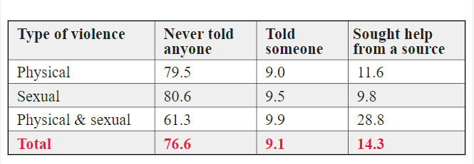
Source: National Family Health Survey 2015-16
Aljazeera reports cases of Domestic Violence of our country and explains the petty reasons why women were thrashed by their respective partners. The aggrieved woman is a 45 year old cook who was habitual of physical abuse from her husband since the beginning of their marriage. But since the woman worked and brought money this violence was terminated by his unemployed husband. Unfortunately, due to COVID 19 the woman’s employer asked her to stay at home until the lockdown ends. The depressing part was that she was not being paid since she worked only for a few days that month. The husband was alcohol deprived and had an unpleasant mood, which resulted him in physically assaulting his wife. Normally, women run to the streets of the slum and they are saved by their neighbors but due to the lockdown they were attacked by the police to remain inside their homes. After viewing the helplessness of the woman, the abusers felt increasingly empowered and they continued doing the crime and this time even more brutally. The police surprisingly also adopted a very traditional approach and said vey casually to the victim to ‘Go home and sort their fight out.’ Although the National Commission of Women (NCW) and several NGO’s jointly started working towards this issue and help could be given through WhatsApp and Helpline Numbers which was started by NCW. Women groups anticipated this issue before the Lockdown which is why Protection officers in Chennai were exempted from the Lockdown. Though help was given but not to a very huge number due to the limitations of the Lockdown. Another case during the Lockdown period, wherein a woman worked in a garment factory and her alcoholic husband was a garbage collector. The husband was so frustrated by the lockdown that he became furious at the mere fact of government telecasting a mythological show Ramayan on Television. This fired up a reason to fight and physically abuse his wife and broke the Television. ‘There goes the Television and the Ramayan’ says the wife mockingly. In such sensitive times of the Pandemic even the slightest of the things were considered as a huge topic to smash their respective partners and sometimes daughters too. This evidently depicts the remorseful plight of the women and the toxic masculinity of the men around us.
The Domestic Violence Act, 2005 informs and educates the aggrieved person about her rights which is enlightened to her by the police, protection officer, service provider or a magistrate. The victim must be educated about the availability of Service Providers, Protection officers and her right to free legal services which is clearly stated under Legal Services Authorities Act, 1987. In addition to this the act also emphasizes about the utilization of Section 498A in cases of Domestic Abuse. Section 3 of the Act defines the act or omission which constitutes an offence of Domestic Violence. Although during these harsh times of the Pandemic, the shelter homes refused to take more persons, but section 6 of the act mentions about the duties of the shelter homes and its inability to refuse a victim of violence. Further the protection officer or the Service provider who are duly registered under Section 10(1) of the Domestic Violence Act should prepare a report for submission to the police officer and magistrate of the area compulsorily. Also a thorough medical examination of the victim shall be conducted and free legal assistance is provided, but this task becomes slightly difficult due to the medical urgency and the restrictions imposed. Though in times of the pandemic these processes may take a bit longer but with governmental assistance and support these issues can also be resolved. Most importantly helpline numbers, the process and the provisions should be widely circulated through social networking sites, Television, Radios and newspapers so that so the information reaches the correct ears and is enacted upon. Recently, we observed a documentary which included notable celebrities speaking about the griming issue of Domestic Violence and emphasized on the Reporting of cases of violence if any near our neighborhood. Technology has proved to be a boon to the victims wherein an application of relief to magistrate can be made with just a click of a button. Though there are problems in the villages particularly where women often do not have access to mobile phones, nonetheless, presence of a single protection officer in a village can help cure this problem too. Maintenance to the victim is similar to as provided under Section 125(1) Code of Criminal Procedure. Section 304 B includes harassment and death due to dowry and mentions the general conditions and circumstances under which dowry death is caused. Section 306 If the base is set then rest of the things automatically fall in place, be it compensation, online hearings (during the lockdown times), restraining order or declaration of a service notice. Furthermore, the victim cannot be thrown out of her house, despite the pandemic times or not, as according to Section 17 of the Right to reside in a shared household.
The victim must not consider themselves to be impotent in such a vulnerable situation. As it is truly said, “Precaution is better than cure” such is the case with crime. The victim must act immediately act when she is attacked by the abusive partner/acquaintance and reach out to the police. As mentioned by panelist Ms. Indira Jaising that even a warning call from the police to the attacker saves the matter from a further fatal attack as it creates a slight fear in the mind of the abuser. Indian Penal Code Section 498A acts a remedy as it introduces punishment with imprisonment which can be extended to 3 years and fine. This section penalizes the individual committing the illegal acts/ crimes that direct to domestic violence and cause coercion to either the woman or her family members. In addition to section 498A, Section 509 of the Indian Penal Code which punishes individuals with imprisonment up till 1 year and fine for outraging the modesty of a woman with word, gesture or an act. Thus, no woman shall be held captive for any physical, verbal, mental or a financial abuse. Domestic Violence should be publically condemned and the society if witnesses any such incident around them in times of pandemic should report to the police or the National Commission for Women if the victim does not do so. Members of the Resident’s Welfare Association, at least one due to the lockdown, should visit the abuser’s house and criticize this barbaric act of the person.
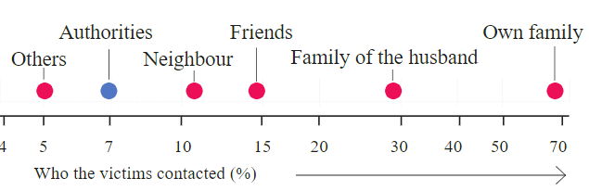
Source: National Family Health Survey
Recently I attended a webinar on this issue of Domestic Violence on 12th May, 2020 which included Hon’ble Smt. Rekha Sharma-Chairperson of National Commission for Women, Hon’ble Dr. Rajulben L Desai-Member of National Commission for Women, P.K Malhotra-Former Secretary Ministry of Law and Justice amongst many others. Smt. Rekha Sharma provided us with many deep insights about the problem of Domestic Violence. She emphasized on the issue that Domestic Abuse during these pandemic times is not only restricted to the lower strata of the population rather the middle and higher levels were also affected greatly. She spoke about the casual response of the audience regarding this problem who ignored it as a family issue. Ms. Sharma clearly mentioned about the WhatsApp Helpline Number which was started under her guidance and read it aloud to the listeners. Dr. Rajulben mentioned to us the statistics of the cases which rose up to 700 out of which 400 were through WhatsApp texts. She also helped us in understanding the difference between cases registered under Section 498A and under Domestic Violence Act, 2005. Dr. Desai explains that the wounds and the torture which can be included under lower degree of violence are filed under Domestic Violence Act, 2005. While, the injuries which are serious and grievous are filed under Section 498A IPC. Further Smt Rekha Sharma mentioned about the policy started by the Central Government under the guardianship of Prime Minister Narender Modi with a project namely “Sakhi” which provides Legal, Financial, Physical and Mental aid to the aggrieved.
Domestic Abuse has its roots deeply embedded in our community and it is an age old concept which has a lot of spectators but not a lot of action takers. Maybe it is because people do not want to step inside another’s household and knowingly make relations awkward for them too. Domestic Violence is also referred to as Intimate Violence due to the fact that people consider it an extremely private and intimate thing. Exactly, this is the barrier which has to be broken and women should start speaking up and seeking help from their neighbors, relatives, police and other authorities. Especially, during these times of the Pandemic wherein women are at the verge of peril of her life, assistance is required and is a must. Recently since the quarantine times, authorities have come up with a signal for help which is a simple hand gesture that can be visually and silently displayed during video calls and will alert friends, neighbors, relatives and the required authorities. I urge the people to kindly check in with the individual as she might be very desperate for help or to at least inform the police or the women cell. This small effort of yours can help in saving someone’s life. I also address to all the abusers to not lose their tempers on their partners and rather support each other during these difficult times. It is not easy for anyone yet we all need to keep going and win from this deadly virus and its after affects one of which is Domestic Violence. I hope and pray all of you the best of health, happiness and peace during this lockdown and for the rest of your lives.

Bibliography
- Humphreys, K., Myint, M., & Zeanah, C. (2020). Increased Risk for Family Violence During the COVID-19 Pandemic. Pediatrics,
- Legal, I. (2020). DOMESTIC VIOLENCE AMID LOCKDOWN: THE SHADOW PANDEMIC. Retrieved 12 May 2020 from https://www.indialegallive.com/special/domestic-violence-amid-lockdown-the-shadow-pandemic-98540
- Ndedi, A., & Kem, J. (2020). Framework in Ending Violence Against women and Girls with the Advent of the COVID 19 from an African Perspective. SSRN Electronic Journal.
- Carvalho, T. (2020). COVID-19 Research in Brief: 24 April to 1 May, 2020. Nature Medicine.
- The graphs and figures mentioned above have been extracted from THE HINDU published on June 22, 2020.

