DV ACT NOTES
CONTENT
INTRODUCTION…………………………………………………………….. Pg 3
OVERVIEW OF THE ACT……………………………..Pg 4-7
SALIENT FEATURES OF THE ACT……………………………………Pg 7- 15
- RIGHTS RECOGNIZED BY THE ACT………………………………… Pg 7-9
- RIGHT TO SECURE HOUSING
- RIGHT TO THE SERVICES AND ASSISTANCE OF THE PROTECTION OFFICER AND SERVICE PROVIDER
- RIGHT TO RECEIVE PROTECTION
- RIGHT TO GET MEDICAL ASSISTANCE, SHELTER, COUNSELLING AND LEGAL AID
- RIGHT TO GET COMPENSATION
- RIGHT TO GET COPIES
- SAFEGUARDS AVAILABLE TO THE VICTIM……………………..Pg 9-15
- PROTECTION ORDER
- MONETARY RELIEF
- CUSTODY ORDER
- COMPENSATION ORDER
- INTERIM AND EX PARTE ORDERS
JURISDICTION………………………………………………………………Pg 15-16
APPEAL………………………………………………………………………….Pg 16
PENALTY………………………………………………………………………..Pg 16-17
CASE LAWS…………………………………………………………………….Pg 17-20
QUERIES………………………………………………………………………..Pg 20-25
ARTICLES………………………………………………………………………Pg 25-26

INTRODUCTION

Since the early eighties women groups have been crusading to bring about effective legislation to respond to domestic violence. In 2001, the Lawyers’ Collective formulated the “Domestic Violence against Women (Protection) Bill”. It takes into consideration several prevalent forms of violence against women and girls within the family and proposes a mechanism for women to approach the court for a protection order to prevent further violence and to ensure that they do not have to leave their home. Extensive discussion among representatives of several NGOs such as the Lawyers’ Collective, the NHRC, the National Commission for Women and the Ministries of Home Affairs, Health and Family Welfare, Social Justice and Empowerment, Elementary Education, Justice and Legal Affairs and Legislative Department during the past few years led to the drafting of the bill, which sought to meet the existing gap in the legal framework. The Protection of Women from Domestic Violence Act, 2005 was brought into force by the Indian Government on October 26, 2006 . The Act was passed by the Parliament in August, 2005 and assented to by the President on 13 September, 2005.
OVERVIEW OF THE ACT
The Domestic Violence Act contains 37 sections which are broadly divided into five chapters.
Chapter I
Deals with preliminary and definition part, it contains Sections 1 & 2.
Chapter II
Deals with the definition of domestic violence under Section 3.
Chapter III
Deals with powers and duties of protection officers, service providers, etc. under Sections 4 to 11.
Chapter IV
Deals with procedure for obtaining orders of relief under Sections 12 to 29.
Chapter V
Deals with miscellaneous provisions under Sections 30 to 37.
What is domestic violence?
Section 3 of the Act defines domestic violence as:
For the purposes of this Act, any act, omission or commission or conduct of the respondent shall constitute domestic violence in case it- (a) Harms or injures or endangers the health, safety, life, limb or well-being, whether mental or physical, of the aggrieved person or tends to do so and includes causing physical abuse, sexual abuse, verbal and emotional abuse and economic abuse; or
(b) Harasses, harms, injures or endangers the aggrieved person with a view to coerce her or any other person related to her to meet any unlawful demand for any dowry or other property or valuable security; or
(c) Has the effect of threatening the aggrieved person or any person related to her by any conduct mentioned in clause (a) or clause (b); or
(d) Otherwise injures or causes harm, whether physical or mental to the aggrieved person.
Explanation I.—for the purposes of this section- (i) “Physical abuse” means any act or conducts which is of such a nature as to cause bodily pain, harm, or danger to life, limb, or health or impair the health or development of the aggrieved person and includes assault, criminal intimidation and criminal force;
(ii) “Sexual abuse” includes any conduct of a sexual nature that abuses, humiliates, degrades or otherwise violates the dignity of woman;
(iii) “Verbal and emotional abuse” includes-
- Insults, ridicule, humiliation, name calling and insults or ridicule especially with regard to not having a child or a male child; and
- Repeated threats to cause physical pain to any person in whom the aggrieved person is interested.
(iv) “Economic abuse” includes—
- Deprivation of all or any economic or financial resources to which the aggrieved person is entitled under any law or custom whether payable under an order of a court or otherwise or which the aggrieved person requires out of necessity including, but not limited to, household necessities for the aggrieved person and her children, if any, stridhan, property, jointly or separately owned by the aggrieved person, payment of rental related to the shared household and maintenance;
- Disposal of household effects, any alienation of assets whether movable or immovable, valuables, shares, securities, bonds and the like or other property in which the aggrieved person has an interest or is entitled to use by virtue of the domestic relationship or which may be reasonably required by the aggrieved person or her children or her stridhan or any other property jointly or separately held by the aggrieved person; and
- Prohibition or restriction to continued access to resources or facilities which the aggrieved person is entitled to use or enjoy by virtue of the domestic relationship including access to the shared household.
Explanation II.—For the purpose of determining whether any act, omission, commission or conduct of the respondent constitutes “domestic violence” under this section, the overall facts and circumstances of the case shall be taken into consideration.
Thus, for the purpose of this Act, any conduct of the respondent shall constitute domestic violence if he-
(a) Habitually assaults or makes the life of the aggrieved person miserable by cruelty of conduct even if such conduct does not amount to physical ill treatment; or
(b) Forces the aggrieved person to lead an immoral life; or
(c) Otherwise injures or harms the aggrieved person
Nothing contained in clause (c) of sub-section (1) shall amount to domestic violence if the pursuit of course of conduct by the respondent was reasonable for his own protection or for the protection of his or another’s property primarily meant to provide protection to the wife or female live-in partner from domestic violence at the hands of the husband or male live-in partner or his relatives, the law also extends its protection to women living in a household such as sisters, widows or mothers . Domestic violence under the Act includes actual abuse or threat of abuse whether physical, sexual, verbal, psychological, emotional or economic. Harassment by way of unlawful dowry demands to the woman or her relatives would also be covered under this definition. Even a single act of commission or omission may constitute domestic violence. This wide definition of domestic violence brings under its purview the invisible violence suffered by a large section of women and entitles them to claim protection from the courts. This legislation has widened the scope of domestic violence and now it can be broadly related to human rights.

SALIENT FEATURES OF THE DOMESTIC VIOLENCE ACT, 2005
RIGHTS RECOGNIZED BY THE ACT
- Right to secure housing
Under section 19 of the Act, she has the right to reside in the shared household. The right also includes her to restraint any other persons residing in the same house if they interfere with or disturb peaceful enjoyment of the house and the facilities thereby provided for her or her children.
- Right to the services and assistance of the protection officer and service provider
Under section 5 of the Act, she can received the assistance of the protection officer and service providers to inform her about her rights and the relief provided under the Act. Also she can seek assistance of the protection officer, service providers or the or the office – in- charge of the nearest police station to assist her in registering her complaint and filing an application for relief under Sections 9 and 10.
- Right to receive protection
Under section 18 of the Act, she has the right to receive protection from the respondent from committing any act of domestic violence, entering the place of employment of the aggrieved person, attempting to communicate in any form, alienating any assets, or causing violence to the dependents of the aggrieved person.
Right to get medical assistance, shelter, counselling and legal aid under Sections 6, 7, 9 and 14.
- Right to get compensation
Under Section 22 right to get compensation for any physical or mental injury or any other monetary loss due to domestic violence.
- Right to get copies
Under section 23, right to get copies of the complaint filed by her, applications made by her, reports of any medical or other examination that she or her child undergo. And also the copies of any statement recorded by any authority in connection with domestic violence.

SAFEGUARDS AVAILABLE TO THE VICTIM
- Protection Order under section 18
When an application is made to the Magistrate that domestic violence has occurred or is likely to occur, then the Magistrate after hearing both the parties and after considering the domestic incident report, where such a report is made prima facie satisfied that domestic violence has occurred or is likely to occur, he/she can pass a Protection Order in favour of the aggrieved person under Section 1819 and prohibit the respondent from-
(a) committing any act of domestic violence;
(b) aiding or abetting in the commission of acts of domestic violence;
(c) entering the place of employment of the aggrieved person or, if the person aggrieved is a child, its school or any other place frequented by the aggrieved person;
(d) attempting to communicate in any form, whatsoever, with the aggrieved person, including personal, oral or written or electronic or telephonic contact;
(e) alienating any assets, operating bank lockers or bank accounts used or held or enjoyed by both the parties, jointly by the aggrieved person and the respondent or singly by the respondent, including her stridhan or any other property held either jointly by the parties or separately by them without the leave of the Magistrate;
(f) causing violence to the dependants, other relatives or any person who give the aggrieved person assistance from domestic violence;
(g) committing any other act as specified in the protection order.
According to section 25, this order shall be in force till the aggrieved person applied for a discharge.
2. Residence Order under section 19
The residence order protects against dispossession from the shared household, prevents any act that impacts upon peaceful occupation of the same and where the need arises, makes provision for alternate accommodations.
(1) While disposing of an application under sub-section (1) of section12, the Magistrate may, on being satisfied that domestic violence has taken place, pass a residence order--

(a) restraining the respondent from dispossessing or in any other manner disturbing the possession of the aggrieved person from the shared household, whether or not the respondent has a legal or equitable interest in the shared household;

(b) directing the respondent to remove himself from the shared household;

(c) restraining the respondent or any of his relatives from entering any portion of the shared household in which the aggrieved person resides;

(d) restraining the respondent from alienating or disposing off the shared household or encumbering the same;

(e) restraining the respondent from renouncing his rights in the shared household except with the leave of the Magistrate; or

(f) directing the respondent to secure same level of alternate accommodation for the aggrieved person as enjoyed by her in the shared household or to pay rent for the same, if the circumstances so require:
Provided that no order under clause (b) shall be passed against any person who is a woman.

(2) The Magistrate may impose any additional conditions or pass any other direction which he may deem reasonably necessary to protect or to provide for the safety of the aggrieved person or any child of such aggrieved person.

(3) The Magistrate may require from the respondent to execute a bond, with or without sureties, for preventing the commission of domestic violence.

(4) An order under sub-section (3) shall be deemed to be an order under Chapter VIII of the Code of Criminal Procedure, 1973 (2 of 1974) and shall be dealt with accordingly.

(5) While passing an order under sub-section (1), sub-section (2) or sub-section (3), the court may also pass an order directing the officer in charge of the nearest police station to give protection to the aggrieved person or to assist her or the person making an application on her behalf in the implementation of the order.

(6) While making an order under sub-section (1), the Magistrate may impose on the respondent obligations relating to the discharge of rent and other payments, having regard to the financial needs and resources of the parties.

(7) The Magistrate may direct the officer in-charge of the police station in whose jurisdiction the Magistrate has been approached to assist in the implementation of the protection order.

(8) The Magistrate may direct the respondent to return to the possession of the aggrieved person her stridhan or any other property or valuable security to which she is entitled to.
- Monetary Order under section 20
(1) While disposing of an application under sub-section (1) of section 12,the Magistrate may direct the respondent to pay monetary relief to meet the expenses incurred and losses suffered by the aggrieved person and any child of the aggrieved person as a result of the domestic violence and such relief may include, but not limited to,--

(a) the loss of earnings;

(b) the medical expenses;

(c) the loss caused due to the destruction, damage or removal of any property from the control of the aggrieved person; and

(d) the maintenance for the aggrieved person as well as her children, if any, including an order under or in addition to an order of maintenance under section 125 of the Code of Criminal Procedure, 1973 (2 of 1974) or any other law for the time being in force.

(2) The monetary relief granted under this section shall be adequate, fair and reasonable and consistent with the standard of living to which the aggrieved person is accustomed.

(3) The Magistrate shall have the power to order an appropriate lump sum payment or monthly payments of maintenance, as the nature and circumstances of the case may require.

(4) The Magistrate shall send a copy of the order for monetary relief made under sub-section (1) to the parties to the application and to the in charge of the police station within the local limits of whose jurisdiction the respondent resides.

(5) The respondent shall pay the monetary relief granted to the aggrieved person within the period specified in the order under sub-section (1).

(6) Upon the failure on the part of the respondent to make payment in terms of the order under sub-section (1), the Magistrate may direct the employer or a debtor of the respondent, to directly pay to the aggrieved person or to deposit with the court a portion of the wages or salaries or debt due to or accrued to the credit of the respondent, which amount may be adjusted towards the monetary relief payable by the respondent

- Custody Order under section 21
Custody Orders- Notwithstanding anything contained in any other law for the time being in force, the Magistrate may, at any stage of hearing of the application for protection order or for any other relief under this Act grant temporary custody of any child or children to the aggrieved person or the person making an application on her behalf and specify, if necessary, the arrangements for visit of such child or children by the respondent.
Provided that if the Magistrate is of the opinion that any visit of the respondent may be harmful to the interests of the child or children, the Magistrate shall refuse to allow such visit.
- Compensation order under section 22
In addition to other reliefs as may be granted under this Act, the Magistrate may on an application being made by the aggrieved person, pass an order directing the respondent to pay compensation and damages for the injuries, including mental torture and emotional distress, caused by the acts of domestic violence committed by that respondent.
- Interim and Ex parte Orders under section 23
Power to grant interim and ex parte orders:-
(1) In any proceeding before him under this Act, the Magistrate may pass such an interim order as he deems just and proper.
(2) If the Magistrate is satisfied that an application prima facie discloses that the respondent is committing, or has committed an act of domestic violence or that there is a likelihood that the respondent may commit an act of domestic violence, he may grant an ex parte order on the basis of the affidavit in such form, as may be prescribed, of the aggrieved person under Section 18, Section 19, Section 20, Section 21 or, as the case may be, Section 22 against the respondent.
According to Section 26, any relief available under sections 18 to 22 may also be sought in any legal proceeding, before a civil court, family court or a criminal court, affecting the aggrieved person and the respondent whether such proceeding was initiated before or after the commencement of this Act.
JURISDICTION
According to section 27, the jurisdiction lies within the local limits of which –
- the person aggrieved permanently or temporarily resides or carries on business or is employed; or

- the respondent resides or carries on business or is employed; or

- the cause of action has arisen, shall be the competent court to grant a protection order and other orders under this Act and to try offences under this Act.
APPEAL
According to section 29, an appeal shall lie to the Court of Session within thirty days from the date on which the order made by the Magistrate is served on the aggrieved person or the respondent, as the case may be, whichever is later.
PENALTY
The Protection of Domestic Violence Act, 2005 provides civil remedies for women facing domestic violence in the form of protection orders, residence orders, custody orders, monetary reliefs or compensation orders, and makes the breach of protection orders punishable under Section 31 of the Act. The punishment given is imprisonment up to a period of one year and fine of up to Rupees Twenty Thousand. Section 31(3) also specifies that while framing charges under Sub-section (1) the Magistrates may also frame charges under Section 498A of the Indian Penal Code (45 of 1860) or any other provision of that Code or the Dowry Prohibition Act, 1961 (28 of 1961), if the facts disclose the commission of an offence under those provisions. This offence is however cognizable and non-bailable under section 32 of the Act.
Similarly, Section 33 provides for a penalty when there is non-compliance or discharge of duties by the Protection Officer. No prosecution or other legal proceeding shall lie against the Protection Officer unless a complaint is filed with the previous sanction of the State Government or an officer authorised by it in this behalf under section 34 and no suit shall lie against a Protection officer who has acted in good faith under section 35.
IMPORTANT CASE LAWS
In S.R. Batra and Anr. vs. Smt. Taruna Batra, the Hon’ble Supreme Court held that the definition of “Shared Household” in Section 2(s) of the Protection of Women from Domestic Violence Act, 2005 is not a very happily worded, and appears to be the result of clumsy drafting. Giving sensible interpretation to the definition of “Shared Household”, the Supreme Court opined that the wife is only entitled to claim a right to residence in a shared household, and a “Shared Household” would only mean the house belonging to or taken on rent by husband, or the house which belongs to the joint family of which the husband is a member. If the property neither belongs to the husband nor is it a joint family property of which the husband is a member, it cannot be called “Shared House hold”.
In Sabita Mark Burges v. Mark Lionel Burges, the court held that under Section 19(1)b of the DV Act, the respondent be denied the right to live in the matrimonial home despite he being the owner of such shared household. The object behind this lies on the idea that even though he is an owner of the household he does not have any right to subject his wife to domestic violence.
In Roma Rajesh Tiwari vs. Rajesh Dinanath, the court held that the woman had a right to reside in her matrimonial home or shared household. It stated that the object of the Domestic Violence Act was enacted to secure the right of a woman to reside in her matrimonial home. The court also stated that 'whether or not the respondent has a legal or equitable interest in the shared household' are of utmost significance, when the right of the aggrieved person, i.e. the wife, is to be decided so far as her residence in shared household is concerned.
It is also irrelevant whether the Respondent has a legal or equitable interest in the shared household. The moment it is proved that it was a shared household, as both of them had, in their matrimonial relationship, i.e. domestic relationship, resided together there and in this case, up to the disputes arose, it follows that the Petitioner-wife gets right to reside therein and, therefore, to get the order of interim injunction, restraining Respondent-husband from dispossessing her, or, in any other manner, disturbing her possession from the said flat.

In Meenavathi v. Senthamarai Selvi, the court held that in the guise of passing an order under Section 19(1)(b) of Domestic Violence Act, such women members of the family cannot be directed to be removed from the shared household.

In Lalita Toppo v. State of Jharkhand & Anr, the court held that maintenance can be claimed under the provisions of the Protection of Women from Domestic Violence Act, 2005 (Domestic Violence Act) even if the claimant is not a legally wedded wife and therefore not entitled to claim of maintenance under Section 125 of Code of Criminal Procedure. The Bench explained that the provisions contained in Section 3(a) of the Domestic Violence Act, 2005 which defines the term “domestic violence” also constitutes “economic abuse” as domestic violence. The Court further opined that under the provisions of the Domestic Violence Act, the victim i.e. estranged wife or live-in-partner would be entitled to more relief than what is contemplated under Section 125 of the CrPC i.e. to a shared household also.
In Krishna Bhatacharjee v. Sarathi Choudhury and Another, while considering the judgment of the lower court, the Supreme Court held that it is the duty of the Court to scrutinise the facts from all angles whether a plea advanced by the respondent to nullify the grievance of the aggrieved person is really legally sound and correct. The principle “justice to the cause is equivalent to the salt of ocean” should be kept in mind. The Court of Law is bound to uphold the truth which sparkles when justice is done. Before throwing a petition at the threshold, it is obligatory to see that the person aggrieved under such a legislation is not faced with a situation of non-adjudication, for the 2005 Act as we have stated is a beneficial as well as assertively affirmative enactment for the realisation of the constitutional rights of women and to ensure that they do not become victims of any kind of domestic violence.
In Suresh Khullar v. Vijay Kumar Khullar, it was held that a husband’s second marriage was legally valid for the purposes of his wife’s maintenance claim during divorce proceedings under Section 18 of the Hindu Adoptions and Maintenance Act of 1956, even if the husband’s ex parte divorce from his first wife had been set aside. The Court relied on Sections 2(a), 18, 20, and 26 of the PWDVA and found that the divorce decree was in operation on the day the second marriage was solemnized, making the parties’ second marriage legally valid, thus, allowing for the wife’s recovery and denying the husband immunity for defrauding her. Husband’s ex parte divorce from his first wife had been set aside. The Court relied on sections 2(a), 18, 20, and 26 of the PWDVA, and found that the divorce decree was in operation on the day the second marriage was solemnized, making the parties’ second marriage legally valid, thus allowing for the wife’s recovery and denying the husband immunity for defrauding her some Judgment is very judicious. Judges do take a substantive approach of the legislation while deciding cases. Formal approach does not always fulfil the intention of legislation. Therefore, judicial approach plays a vital role for achievement of object.

QUERIES
- Attached below are various queries with respect to DV Act asked on lawyersclubindia.com. Please refer the following for your further understanding.
Query I

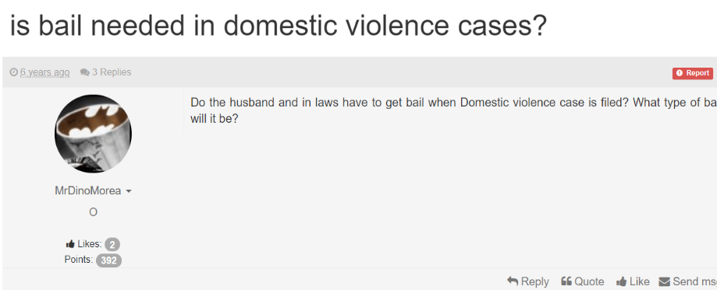



- Query II

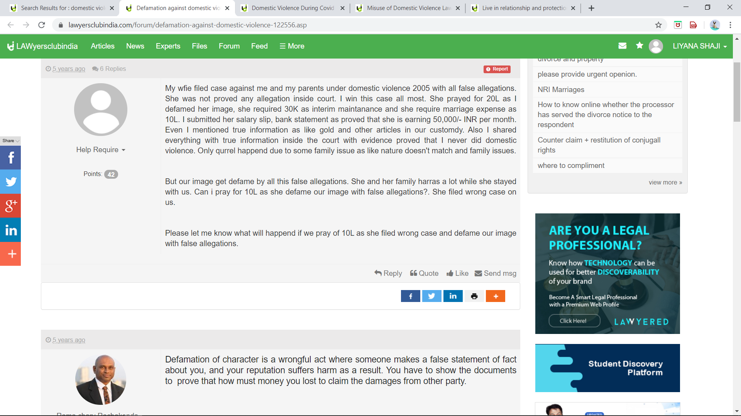
- Query III

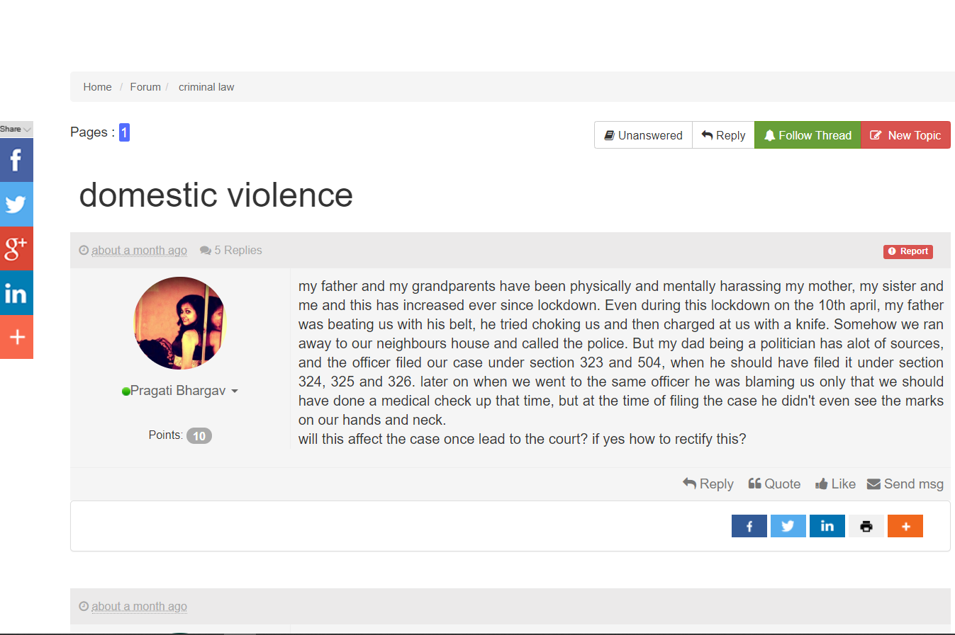

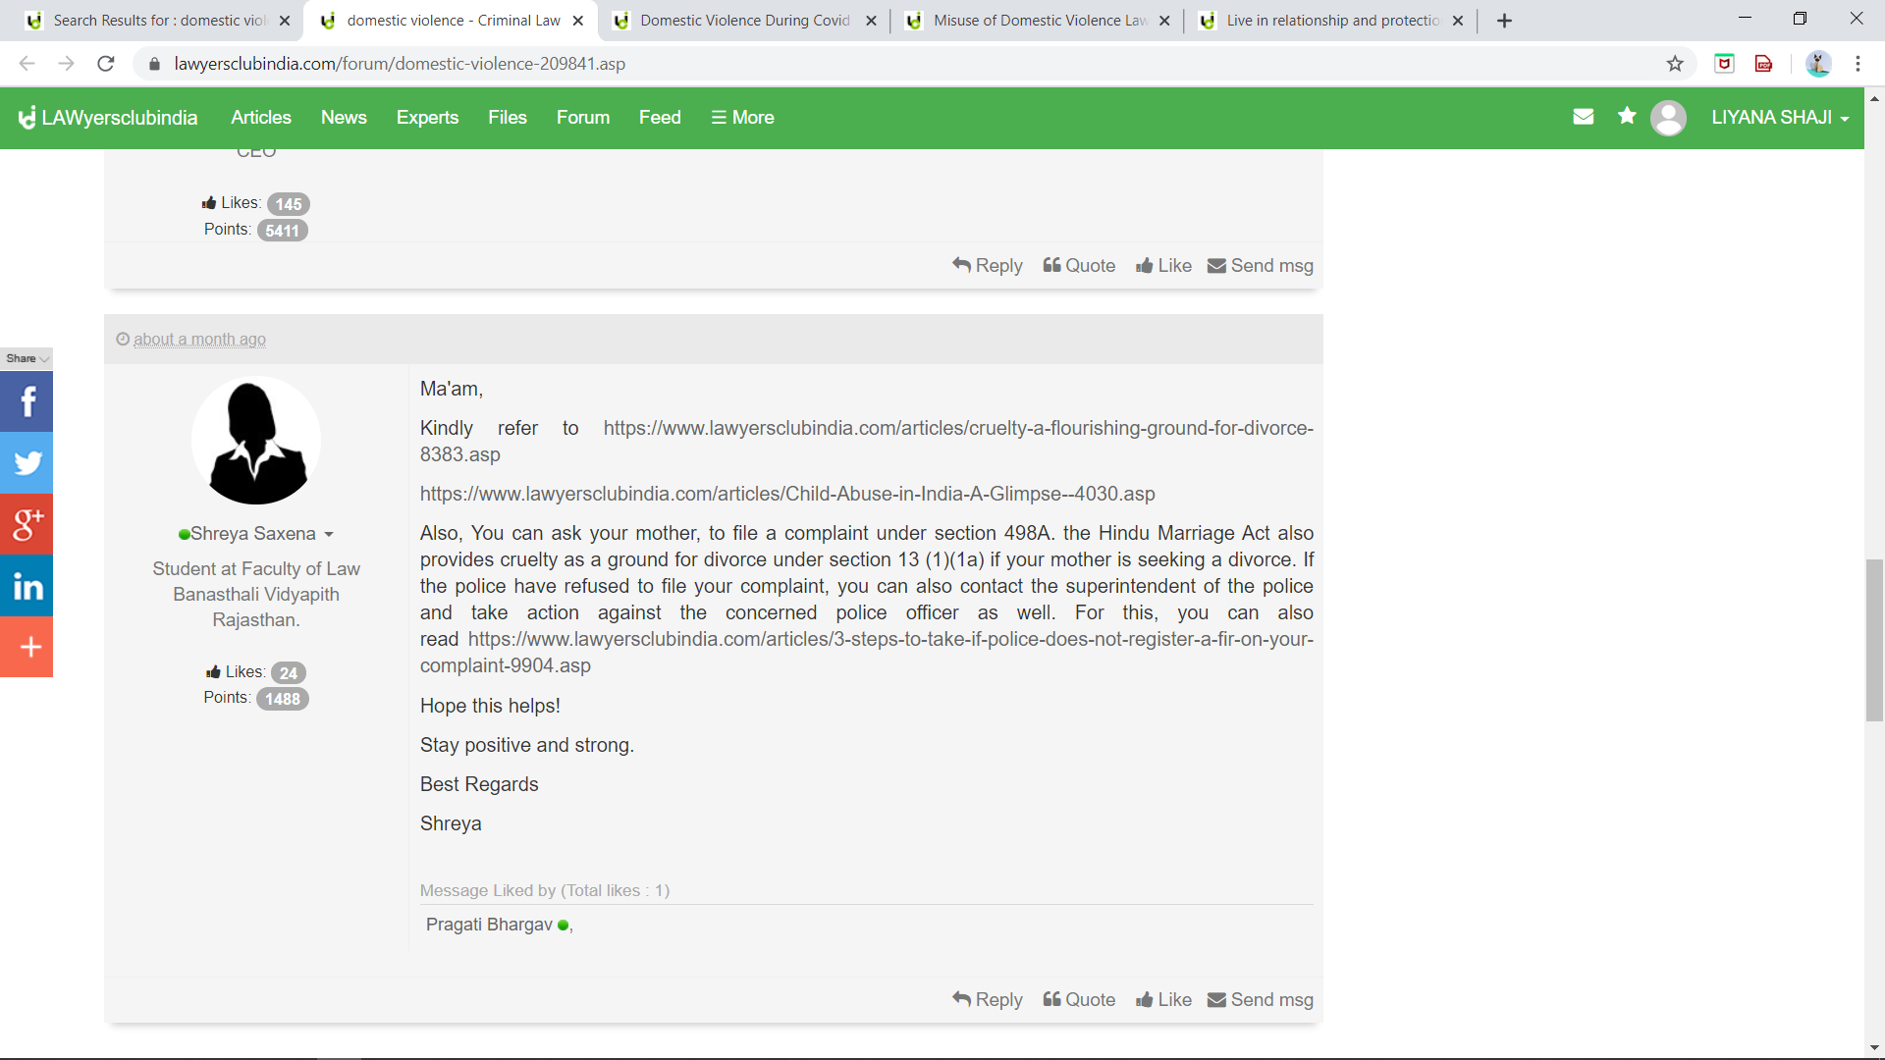
- Query IV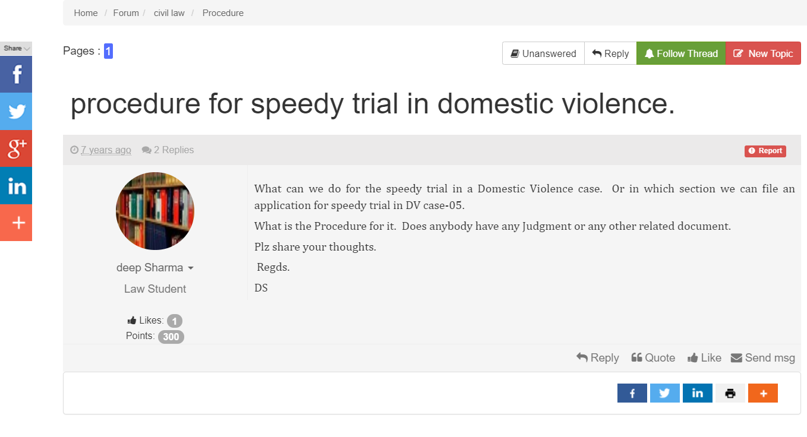
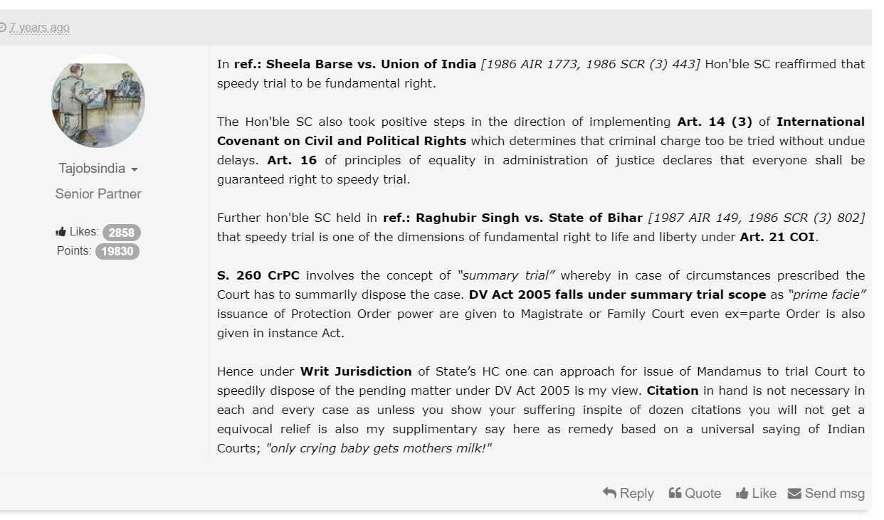
- Query V
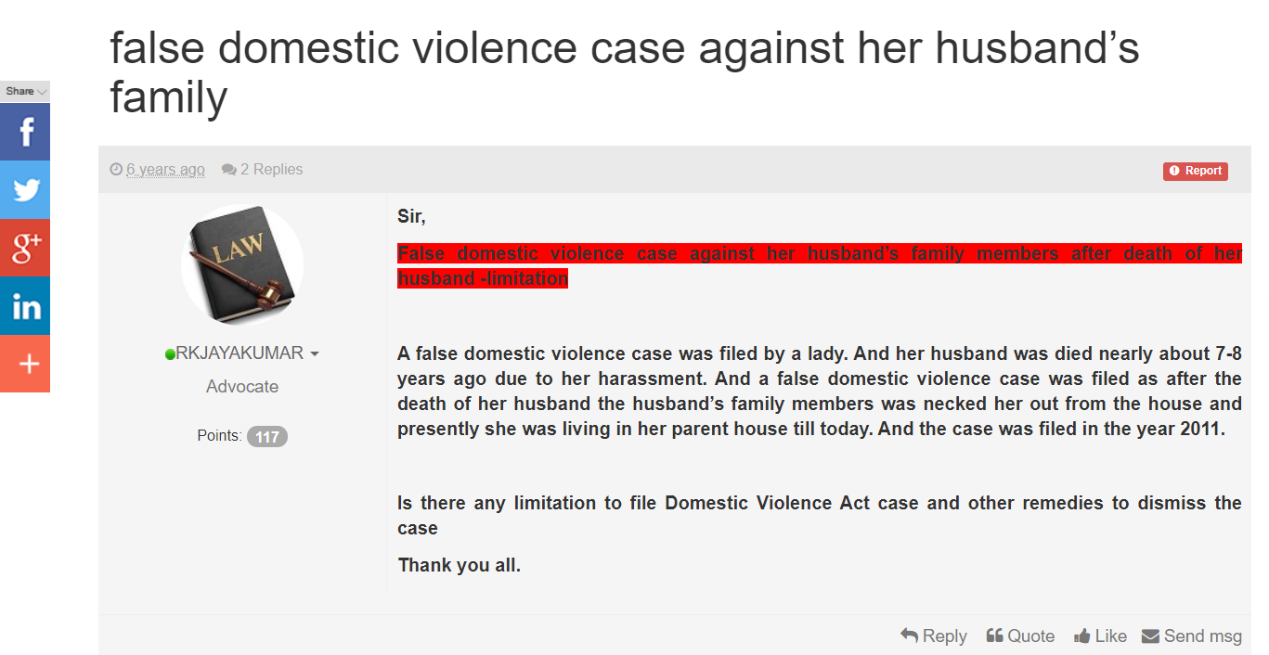
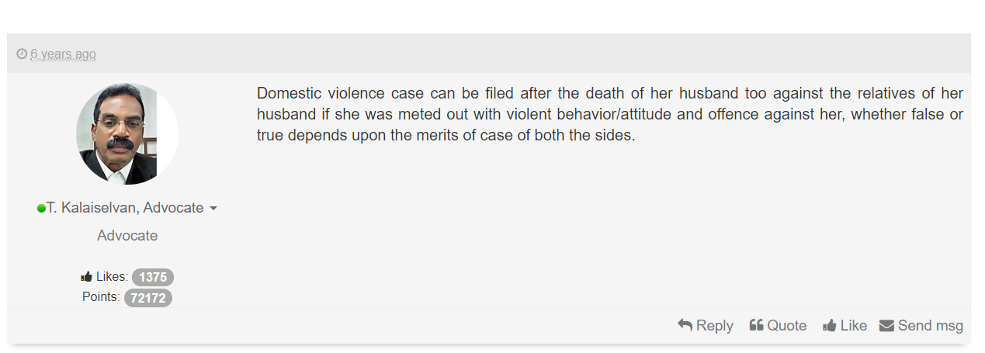
ARTICLES
- Attached below are various articles based on DV Act published on lawyersclubindia.com. Please refer the following link for further understanding.
1. Domestic violence during COVID-19
https://www.lawyersclubindia.com/articles/domestic-violence-during-covid-19-crime-behind-the-closed-doors--11262.asp
2. Misuse of domestic violence laws
https://www.lawyersclubindia.com/articles/misuse-of-domestic-violence-laws-a-legislative-dynamism-9169.asp
3. Live- in relationships and protection of women from Domestic violence https://www.lawyersclubindia.com/articles/live-in-relationship-and-protection-of-women-from-domestic-violence-act-2005-7565.asp
4. Domestic violence- A curse in the society
https://www.lawyersclubindia.com/articles/domestic-violence-a-curse-in-the-society-a-global-epidemic-5073.asp
5.Domestic violence against men
https://www.lawyersclubindia.com/articles/domestic-violence-against-men--520.asp

Preeti Misra, Domestic Violence against Women legal control and judicial response (New Delhi: Deep and Deep Publication, 2006), p. 346.
P.K. Das, Protection of Women from Domestic Violence Act and Rules, 3rd edn. (New Delhi: Universal Law Publishing Co. Pvt. Reprint, 2010), p.19
AIR 2007 SC 1118
2013(4)ABR542
MANU/MH/2465/2017
CRL.O.P.(MD)No.12092 of 2008 AND M.P.(MD)Nos.1&1 of 2008
CRIMINAL APPEAL NO(S). 1656/2015
2016) 2 SCC 705
AIR 2008 Delhi 1

